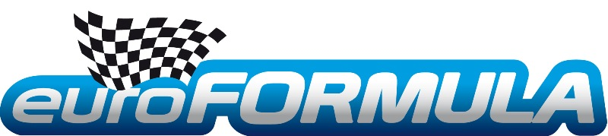
ENZO GUIBBERT WINS THE VOLANT EUROFORMULA 2012

The selections put Pierre COMBOT, Simon TIRMAN, Enzo GUIBBERT, Victor SENDIN, Darius OSKOUI, Maxime RAPHOZ, Joffrey de NARDA, Julien GOUPIL, Jordan PERROY, Cyril RAYMOND and Amaury ROSSERO head-to-head in the semi-final on the LA CHATRE circuit behind the wheels of Formula Renault 2.0s pulled from the hat by the senior instructor Joel de Miguel.
The five best students then moved up into the final which took place the next day in the following order, chosen according to their place in the ranking:
Enzo GUIBBERT (1st in the semi-final), Jordan PERROY (3rd), Pierre COMBOT (2nd), Simon TIRMAN (4th) and Cyril RAYMOND (5th) who will remain the revelation of these semi-finals.
For the final, all the drivers used the same single-seater shod with new tyres worn in by Simon GACHET, the 2011 winner. The best average over five laps would once again be the decider.
When all five drivers had finished, the Presidents, Jean Pierre JAUSSAUD and Philippe SINAULT as well as the Members of the Jury Gilles GAIGNAULT, Pierre GILBERT and Nelson PANCIATICI unanimously declared Enzo GUIBBERT the winner. He succeeds Paul Loup CHATIN and Simon GACHET, the winners of 2010 and 2011.
Pierre COMBOT, whose performance was memorable even though he had not touched the wheel of a single-seater since 2007, finished second in this final and a brilliant and consistent Jordan PERROY stepped up on the third step of the podium.
Enzo GUIBBERT who dominated this final head and shoulders above the others, was awarded the € 60,000 bursary, the RALF TECH WRX Hybrid Steel watch and all the driver equipment from P1 ADVANCED RACEWEAR.
The young man of 17 was visibly moved: "When I came here to take part in the selections in July, I liked the track straight away. I was motivated and came to win. I was focused from the start and I decided to attack from the very first lap. I found a good pace and I felt at ease in the car. Then, as I watched my rivals turns, I thought I could tell that I'd won. Simon Gachet was the first to confirm it to me. I don't know yet what I'm going to do next year, I'm hesitating between the Formula Renault 2.0 or saloon, Porsche GT3 or a Cup. It's not the "heart" that will decide but the budget I can put together along with the award I have won thanks to my victory in the VOLANT EUROFORMULA."
Runner-up, Pierre COMBOT said: "My first lap was good but after that I wasn't able to raise my game, I found it impossible to go faster. Whatever, Enzo was way above the rest of us and he deserves to win. He drove very well. Well done." The opinion is the same for Jordan PERROY. Great sportsmanship on the part of his closest rivals!
Laurent FRADON, the Director of the EUROFORMULA School was delighted: "Enzo dominated this VOLANT from the semi-finals and he thoroughly deserves his victory. This win was without a fault! He didn't buckle under the pressure. Well done, his young career looks promising. We will follow him closely all next year, he is one of the most talented students we've had at the school!"
The final word comes to Jean Pierre JAUSSAUD and Philippe SINAULT, the Presidents of the Jury: "Enzo stifled the competition with the fastest laps thanks to his aggressive driving which is what we look for. It was clear. He is the Volant 2012!"
The date is set for the final of the "VOLANT EUROFORMULA" 2013 with some important changes which should help the young drivers progress in the best possible conditions.


www.euroformula.com

