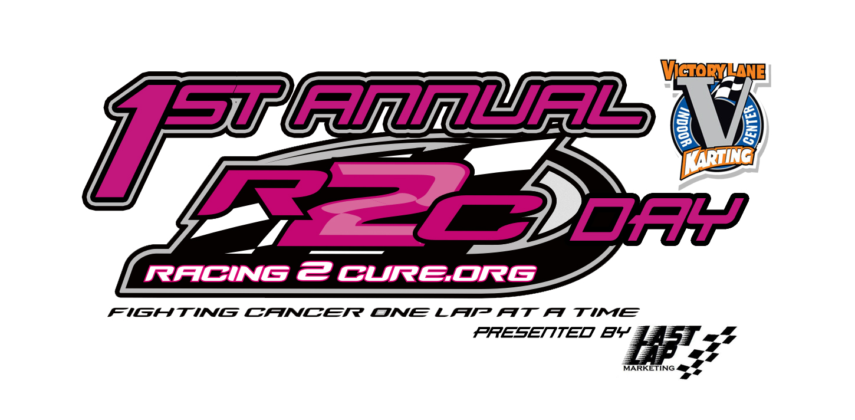
Bradley Carpenter
Last Lap Marketing, Owner
704-860-6803
brad@lastlapmarketing.com

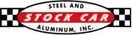
FOR IMMEDIATE RELEASE

Stock Car Steel and SRI Racing Supplies Join the Fight Against Cancer
Mooresville Racing Company Comes on Board for 1st Annual Racing 2 Cure Day

CHARLOTTE, NC (April 2, 2013) – Last Lap Marketing is pleased to welcome Stock Car Steel and SRI Racing Supplies on board for the 1st Annual Racing 2 Cure Day at Victory Lane Karting occurring on Friday April 5. The event will take place at VLK from 11am till closing, midnight.

Stock Car Steel and SRI Racing Supplies will be providing a NASCAR Sprint Cup All Star Race package that includes access to the Billy Currington pre-race concert, which will be raffled off to raise more funds for Racing 2 Cure. In addition, for every race that is purchased on April 5, $5 will go to Racing 2 Cure. In addition, VLK will suspend normal pricing and will have the following price bracket: 1 race $20, 2 races $40, 3 races $50, and 4 races for $65. Throughout the evening portion of the event, 7-10PM, several different activities will be occurring in which the community can take part in. There will be raffles, picture opportunities; the Racing 2 Cure Bandolero race car will be present, and more! Further details on what will be happening during the event will be located on Last Lap Marketing’s website, www.lastlapmarketing.com.

“It’s great to see Belmont Abbey College students taking on ambitious projects. They have chosen to promote a great cause, and they are taking the connections made through the Motorsports program to make things happen,” said Chase Forbes, a former Belmont Abbey Motorsports student and current marketing team member at Stock Car Steel and SRI Racing Supplies. “Stock Car Steel and SRI have been involved with colleges for years, mainly with engineering schools, because they use the products that we sell. With projects such as this Racing 2 Cure event at VLK, we can actually get involved with schools like Belmont Abbey. While Abbey students aren’t known for wearing welding helmets, we’re still able to donate things like tickets to the All-Star race.”

-30-

Victory Lane Karting
2330 Tipton Dr. Ste. 100
Charlotte, NC 28206
Phone: 704-377-FAST

Stock Car Steel & Aluminum, Inc. was founded by Greg Fornelli in 1996 to serve the extremely demanding world of NASCAR racing. Better than 90% of all NASCAR race teams are located within a 100 mile radius of our 35,000 ft² Distribution Center. We are the primary Metal and Plastics supplier to just about all of them. We service all business in our local market with our own fleet of trucks and are happy to deliver, free of charge.

Racing 2 Cure began as a simple act of then 7-year old Hunter Stewart. Hunter was just starting his off-road racing career when he received troubling news. Just a few weeks before his first-ever race, his Mom at just 34-years old, was diagnosed with Breast Cancer. In order to maintain a positive focus, the family decided to continue racing. After attending an event held by Susan G. Komen for the Cure (R), Hunter was inspired to take action. He carried the Komen logo on his race truck, wore pink shoe laces, and gave one-weeks’ worth of his allowance for every race lap he completed. This one-race effort inspired others to take action. Hunter's story was largely covered by the media and recognized by public officials, including a guest appearance on the Ellen DeGeneres Show.

After several treatments Hunter's Mom (Alycia) went into remission (for three years.) Unfortunately Alycia was diagnosed again with Breast Cancer. She is currently in remission from her second fight with cancer. Alycia's cancer has taught the Stewart family the first hand hardships that Cancer brings to families. It was ‘families’ in need while undergoing treatment that inspired the formation of Racing 2 Cure Non-Profit Organization.

Victory Lane Karting is an indoor conference center, race facility, and entertainment venue located in the heart of Charlotte, NC. Our 1/3 mile road course is the fastest in the Carolinas and one of the fastest in the nation. Sodi Honda top-of-the-line racing karts challenge any driver with top speeds of 45 mph at 2” off of the ground. Victory Lane Karting can host any type of event you are looking for, from a small group of 8 to a large group of 1000. If it's a teambuilding exercise for your company, a children’s birthday party, a product launch or just some friends looking for something exciting and different to do, VLK is YOUR PLACE TO RACE as well as a top-notch facility for any kind of event. Please check out the rest of our website and call us at 704-377-FAST (3278) with any questions.

