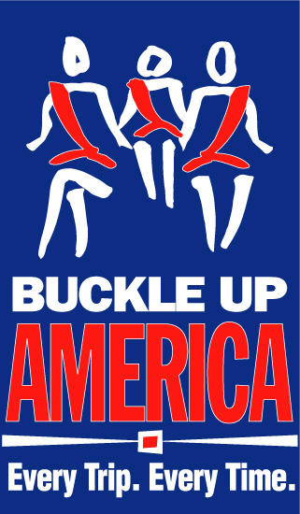
Buckle Up. Every Trip. Every Time.
2013 Thanksgiving Planner
Fact Sheet

Ensure Safe Travels This Thanksgiving Holiday
Buckle Up America – Every Trip, Every Time.

- The Thanksgiving holiday is one of the busiest travel times of the year, and with all the excitement, travelers can become more focused on celebrations than getting to their destinations as safely as possible.

- Wearing a seat belt is the single most effective way to save your life and the lives of your loved ones while on the road. Don’t risk it on the road this Thanksgiving. Remember: Buckle Up America-- Every Trip, Every Time.

- According to the U.S. Department of Transportation’s National Highway Traffic Safety Administration (NHTSA), seat belts saved almost 12,000 lives nationwide in 2011.

- In the same year, 52 percent of the 21,253 passenger vehicle occupants killed in motor vehicle crashes were NOT wearing seat belts at the time of the crash.

- During the 2011 Thanksgiving holiday (6:00 p.m. on Wednesday, November 23, to 5:59 a.m. on Monday, November 28), 249 passenger vehicle occupants were killed in motor vehicle traffic crashes nationwide. Fifty percent of those killed were not wearing seat belts.

- Nighttime (6 p.m. to 5:59 a.m.) is an especially dangerous time because people are less likely to wear a seat belt. Nationally in 2011, 62 percent of the 10,135 passenger vehicle occupants who were killed in nighttime crashes were not wearing their seat belts, compared to 43 percent during the daytime hours.

- Throughout the 2011 Thanksgiving holiday period, 57 percent of the passenger vehicle occupants killed in nighttime crashes were unbelted, while only 40 percent of those killed in daytime crashes were unbelted.

- Research shows that with proper seat belt use, the risk of fatal injury to front seat passengers is reduced by 45 percent, and the risk of moderate to serious injury is reduced by 50 percent.

- With the help of highway safety advocates and local law enforcement officers across the country, we can increase seat belt use and save lives on our roadways.

- For more information about traveling during the Thanksgiving holiday, please visit www.trafficsafetymarketing.gov.

