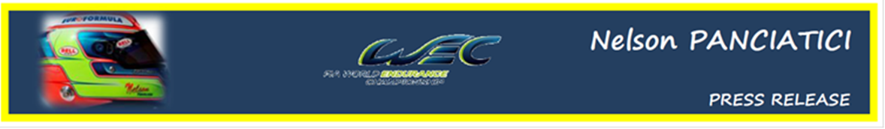
FIA WORLD ENDURANCE CHAMPIONSHIP – ROUND 4:
6 HOURS OF SILVERSTONE (25 & 26 August 2012)

NELSON PANCIATICI ON THE PODIUM

The whole G DRIVE RACING by SIGNATECH NISSAN was impatient to get to Silverstone and set a positive dynamic before attacking the second part of the championship. Nelson Panciatici and his co-drivers, the Frenchman Pierre Ragues and the Russian, Roman Rusinov, reached their objective with a superb podium after six hours of an endurance race worthy of an F1 Grand Prix. It's a just reward for the whole G DRIVE RACING by SIGNATECH NISSAN team who were impeccable both in car preparation and refuelling, beating all competition.
High-performance from the start of the free practice, Nelson Panciatici made the fourth best time and first of the ORECA 03 chassis in the first session.The team of the #26 took on the race with equanimity despite some difficult qualifiers.
At mid-race, and after some solid relays completed by his co-drivers, Philippe Sinault sent Nelson Panciatici into "battle" for a quadruple relay. The young G-DRIVE driver then fought to the end to put his ORECA 03 NISSAN on the best spot of the podium before he was held up by a competitor in LMP2 who, despite his 6 lap lag, obviously did not see the blue flags. There was nothing left to do then but "roll out" to the chequered flag. It was a shame because Nelson finished less than 25 seconds behind the winners!
Nelson: "It was "full" attack for 182 laps, a total pleasure especially when I was fighting it out with Stephane Sarrazin. We had the same pace but he was better in traffic, I learnt a lot behind him! I've made more progress in this field but I've got to say I lived through some hair-raising moments. To finish on the podium in my 3rd proto race is really satisfying but I was a bit disappointed at the finish because we were in line for a victory. I gave it everything I had and I didn't suffer at all physically despite my quadruple relay. We have a really efficient and complementary team. The understanding we have with our engineer, Damien, is perfect. We should be able to bring the team some more satisfactions in the next meetings. In any case we will do what it takes to make our presence known!"
Philippe Sinault, the manager of the G DRIVE RACING by SIGNATECH NISSAN team, is just as satisfied with the result: "It was a fantastic race! 6 hours of F3 Grand Prix, I loved it! The team were exemplary as much with the preparation of the car which did not have any problems as with the pit stop management. Their interventions were the fastest of all the pits. All these elements contributed to the very good result this weekend. Pierre started the race really well, Roman had a solid double relay, and Nelson had the 'knife between his teeth' for the quadruple. In one word, the team was fantastic."
The next meeting is on the famous F1 circuit for the 6 Hours of Sao Paulo in Brazil which takes place on the 14 and 15 September.

For more information on Nelson PANCIATICI, please visit www.nelsonpancia.fr
Join Nelson's Fan Club on Facebook!

