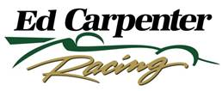

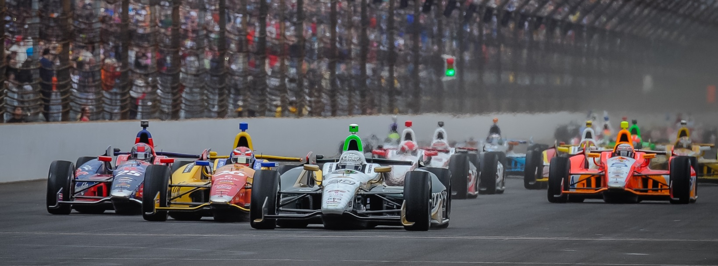

For Immediate Release Contact: Tom Blattler

317-525-5692

**FORMER LBGP CHAMP CONWAY READY WITH ECR/FUZZY’S CHEVY**

**FOR “ROAR BY THE SHORE” IN 40TH LONG BEACH CLASSIC**

**2011 Long Beach Winner Comes Off Impressive Drive at St. Pete**

**LONG BEACH, Calif.  (April 7, 2014)** – There may not have been anything more inspiring in motorsports than when Mike Conway came back from his brutal Indy 500 injuries to capture the 2011 Toyota Grand Prix of Long Beach.

The personable Brit drove around race leaders Dario Franchitti and Ryan Briscoe late in the 80-lap feature to win his first Verizon IndyCar Series in dramatic fashion. Conway’s hard rehab and fighting spirit to return to the cockpit was one thing, but to win in only his second race back in an IndyCar was a tremendous story.

Now, Conway returns to the challenging 1.923-mile, 12-turn street circuit for the 40th edition of the “Roar by the Shore” with sights on scoring his second Long Beach trophy. This time it is in the seat of the No. 20 Fuzzy’s Ultra Premium Vodka Chevrolet fielded by Ed Carpenter Racing.

Conway has replaced team owner/driver Carpenter in the road and street events for 2014 and the 30-year-old of Sevonoaks, England immediately impressed in his debut run at St. Petersburg. Starting 12th on the grid, Conway drove to the third position by lap 75 before a radio miscommunication cost him a possible podium finish.

“As the day went on, we got to third,” said Conway. “I think we had a different strategy from other people. We made some big gains on the red Firestone tires and drove by many cars. So that was very positive. Then we had a missed radio communication to come into the pits. That is definitely frustrating after driving to third.”

Despite the mishap, Carpenter was pleased with Conway and his team’s on-track performance.

-more-

-2-

“Obviously, at the end of the day, we were a little disappointed with the result,” said Carpenter, the 2013 Indy 500 pole winner. “I think the positives outweigh the negatives. In my mind, we made some major gains with Mike (Conway) and the car throughout the weekend. The pace in the race was very good and the building blocks are there. We made some mistakes and there are things we learned today. I’m pleased how the team came together this weekend. There is some real potential here.”

And that potential could come as soon as this weekend at Long Beach, a place steeped in racing tradition. Something Conway is well-aware of too.

“I had heard about the Toyota Grand Prix of Long Beach as I was growing up in England but I didn’t know the magnitude of the event,” he admits. “I didn’t know the history of the race until I was on the top of the podium after my win and I looked down at the names in victory lane who had won there. And I said, “Bloody Hell, there was a great list of drivers who have won at Long Beach. So it is just so cool to now be a part of that history at Long Beach. Then going back the next year and seeing my name etched in the pavement with the other names is pretty awesome. That victory lane experience really made me sit up and take notice of that race.”

Conway knows what it takes to win at Long Beach and is set for a repeat showing.

“It is very neat to have won at Long Beach,” the 2013 Detroit winner said. “The track is very challenging for a street circuit. There are some very tough sections through it. For a driver, you have to put everything together to get a good lap in qualifying and have a solid car to win the race. I think we can do that this year with the Fuzzy’s Chevy and the ECR team.”

Carpenter is excited for Long Beach too. The two-time Verizon IndyCar Series race winner believes the combination of Conway and the ECR crew was a great decision this winter.

“The move was best for the team and our partners to have Mike drive the road and street races,” Ed said. “While I was improving each year at the road races, this current field is so competitive now that we believed Mike could give the ECR team the best showing in 2014. We saw that already at St. Pete. We are anxious for Long Beach since he is a former winner there.”

With Conway’s knowledge of Long Beach, the race holds a special place for him.

“I always get excited thinking about coming back to Long Beach,” he said. “It’s a legendary event for many reasons. I was able to win the race and that was a special day for me. I had just come back to racing after a tough rehab from the 2010 Indy 500 crash. It was a long road back and I was just getting back into racing form. But that victory, my first IndyCar Series, was a great way to tell everyone that I was back.

“In terms of the street races we go, Long Beach has the most party atmosphere. You are so close to the fans, concerts are happening, parties and events are around the circuit. And the history of the Long Beach race is great too. There are not many tracks we run that have 40 years of history, especially in street races. Maybe it’s Monaco and then Long Beach.”

And Mike Conway wants to add to his legacy at Long Beach with another win this weekend.

# # #