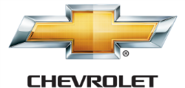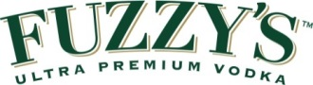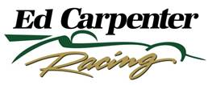

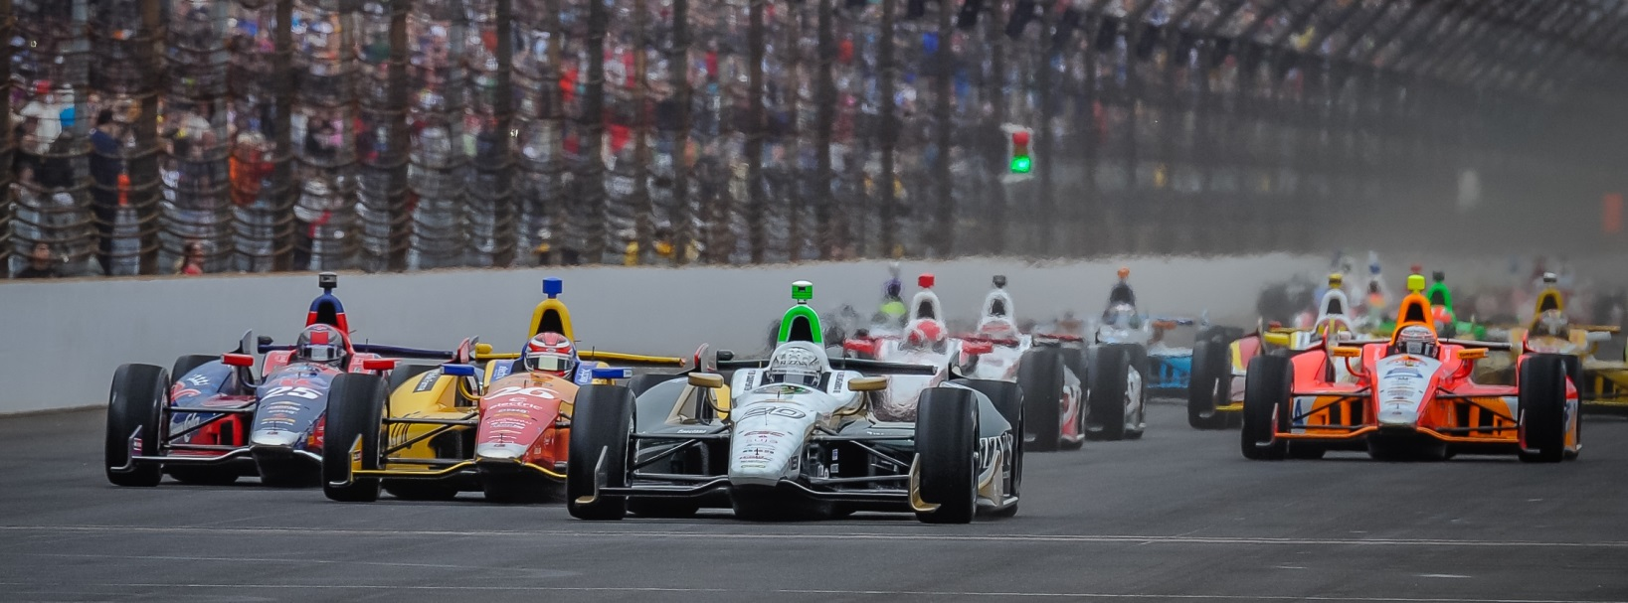

For Immediate Release Contact: Tom Blattler

317-525-5692

**ED CARPENTER FORGETS INDY 500 TROUBLES, SMOKES ‘EM**

**IN GREAT COMEBACK DRIVE SATURDAY NIGHT AT TEXAS**

**Fuzzy’s Vodka Chevy Team Owner/Driver Leads 90 Laps in Firestone 600K**

**FORT WORTH, Texas (June 7, 2014)** – We saw the emotion from Ed Carpenter two weeks ago at this year’s Indianapolis 500, but we saw Carpenter’s impressive driving skill Saturday night at the Texas Motor Speedway.

Carpenter, team owner/driver of the No. 20 Ed Carpenter Racing/Fuzzy’s Ultra Premium Vodka Chevrolet, started fifth and led 90 laps to win the Firestone 600K under the lights in a superb performance. It was Carpenter’s third career Verizon IndyCar Series victory (Kentucky, Fontana and Texas) and the third win for Ed Carpenter Racing (Ed at Fontana 2012 and Texas 2014 and Mike Conway at Long Beach 2014). ECR was started in 2012.

Carpenter, the Indy 500 pole winner, suffered a tough late race result at the 500 when he was knocked out the “Greatest Spectacle in Racing” on lap 175 while running in the second place. But the popular Butler University marketing grad left little doubt of his speed Saturday night at the high-banked 1.45-mile oval north of Ft. Worth. It was Carpenter’s 14th Texas start.

Carpenter, whose best Texas finish was fourth last year entering Saturday’s race, led the 248-lap event three times including 66 of the last 67 circuits to defeat pole sitter Will Power and Juan Pablo Montoya in an all-Chevy podium finish.

Carpenter made a spectacular pass on Power for the lead on lap 182 and widened his margin to 14 seconds before a late race caution flag on lap 241 closed up the field. On the lap 246 restart, Carpenter took the advantage again and won at the checkered flag by .524 seconds with an average speed of 178.301 miles per hour.

The win for Ed Carpenter Racing gives the single-car team two wins in 2014 with its two drivers, Carpenter and Conway, in a unique team setup. Carpenter drives the six oval races and Conway the 12 road races.

-2-

Carpenter has been delighted with the performance of his young single-car operation this year and Saturday night’s performance gave the entire Verizon IndyCar Series notice that the Fuzzy’s Vodka-packed squad will be tough to deal with the remainder of the 2014 season.

“I knew we had a good car,” said Carpenter. “We had a good test here back a couple of months ago. I just felt like we left some on the table in qualifying, but it made me extra motivated for tonight. The first two stints weren’t great. Had one bad stint, but the guys just made great adjustments all night. The Fuzzy’s car was hooked up by the end. I think we were the car to beat at the end. I was a little worried about that last yellow. I knew guys were going to come in and pit. We talked about what we would do in that situation and we were kind of undecided. But Tim (Broyles, team strategist) and the boys made the right call.  It’s an awesome night. I have loved this race track for a long time and had a lot of bad luck here.  I have really always wanted to win here, so I’m super excited.”

While the disappointment of the Indy 500 still lingers with Carpenter, the win on Saturday night helps repair the sting from the race two weeks ago.

“Yeah, we had the car to win Indy,” said Carpenter. “I’m not saying we would have beat Ryan (Hunter-Reay) but I think we were the best chance to have a shot at Ryan. It’s nice to come back here and get a win. I’m really proud of the team’s two wins already this year. It’s a good year.  All the credit goes to the team guys. The awesome pit stops they give Mike Conway and I and the great cars too. And obviously I want to thank Fuzzy’s Vodka for making this all happen.”

There is no rest of the weary at Ed Carpenter Racing as the team begins testing at Iowa this Tuesday and Milwaukee Thursday and the following week at Pocono before the next Verizon IndyCar Series race, the Houston doubleheader on June 28-29 at Reliant Stadium. Conway will drive the Fuzzy’s Vodka Chevy at Houston.

