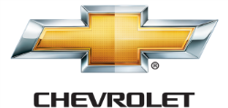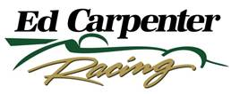

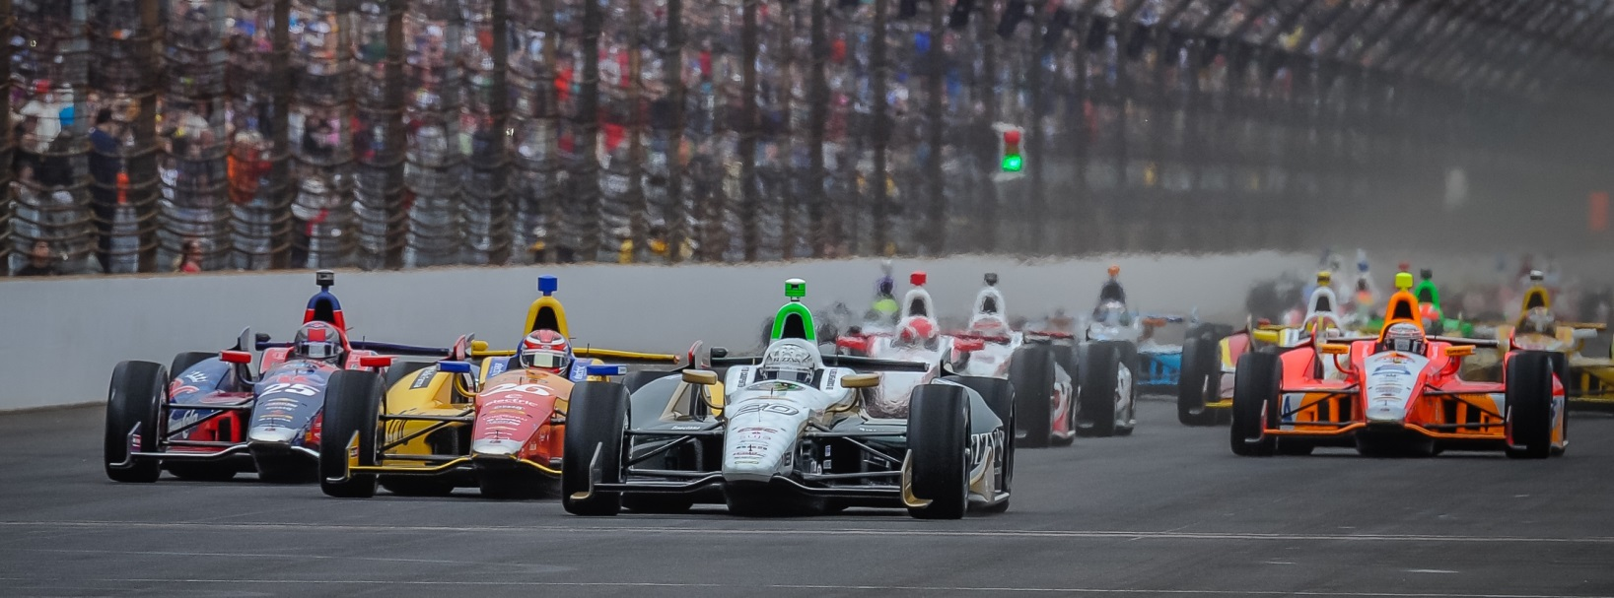

For Immediate Release Contact: Tom Blattler

317-525-5692

**ED CARPENTER BACK IN THE FUZZY’S VODKA CHEVY FOR**

**FAMED MILWAUKEE MILE AND SEEKS 2ND 2014 OVAL VICTORY**

**Texas Winner Ready for Action at Oldest U.S. Race Track**

**WEST ALLIS, Wis. (August 12, 2014)** – Team owner/driver Ed Carpenter enjoys reading about history, especially when it comes to auto racing. So it’s no surprise the owner/driver of the No. 20 Fuzzy’s Ultra Premium Vodka Chevrolet loves the Milwaukee Mile.

The Butler University graduate majored in marketing but he knows a lot about motorsports history and the legendary track at the Wisconsin State Fair Park. The Verizon IndyCar Series returns to famed oval this weekend (August 16-17).

Now Carpenter wants to be part of the oldest U.S. track’s history this weekend in the ABC Supply Wisconsin 350 with his name on the winner’s trophy. Names like Mays, Bettenhausen, Ward, Jones, Foyt, Andretti, Unser, Ruby, Rutherford, Johncock, Dallenbach, Sneva, Mears, Mansell, Tracy and current drivers like Montoya, Bourdais, Dixon, Kanaan, Briscoe and Hunter-Reay have graced victory lane at Milwaukee.

Ed believes this year will be his turn to drive in that hallowed ground.

“I’m a huge fan of the Mile, its setting and its history,” said Carpenter, the recent Texas Motor Speedway race winner. “It’s the oldest operating motor speedway in the North America and I have raced there many times. So winning at the Milwaukee Mile would be a great thrill.”

Carpenter wanted to win at Texas badly too and put on a sensational display for his third win.

“Like Milwaukee, Texas is a favorite track for me,” explained Carpenter, the only owner/driver in the field this weekend. “I have raced at Texas many times and I really wanted to win there. So it was exciting to take the checkered flag. Winning at Milwaukee is a big goal of mine because of its rich history in the sport.”

-more-

-2-

Carpenter is back in the Fuzzy’s Vodka Chevy for the first time in a month after his exciting charge from 14th to fifth at Iowa Speedway in July.

“It will feel good to get back in the Fuzzy’s Chevy again,” said Carpenter, who shares the driving chores of the No. 20 machine with road racing specialist Mike Conway. “Mike and I are the only ones sharing a ride this year but things have worked out pretty well with three wins between us. Now, that he has two victories (Long Beach and Toronto) I would definitely like to match his win count at Milwaukee.”

Carpenter has nine IndyCar Series starts at the Milwaukee Mile but also raced dirt tracks in Wisconsin during his USAC sprint car and midget days.

“The Wisconsin race fans are great and extremely knowledgeable on the history of the open-wheel racing,” said Carpenter. “Of course, look at the names that have competed at the Mile over the years. Wow. That is an impressive list.”

Carpenter understands the legacy of racing in the Badger State too.

“I love the racing scene in Wisconsin,” he said. “I’m an Indiana guy who was raised on famous old tracks like Winchester and Terre Haute and Salem, so I appreciate Wisconsin’s renowned racetracks like Slinger, Beaver Dan, Plymouth and Road America. You can go anywhere in Wisconsin and you won’t be far from a racetrack. That’s what I’m used to in Indiana.”

Carpenter is attempting to continue his team’s 2014 successes with another win this Sunday.

“We’re hoping to be able to continue our momentum from earlier this year,” said Ed. “We have three wins and a pole position at Indy. I’m hoping we can turn that success into victory at Milwaukee too.”

Action at the legendary track begins at 10 a.m. CDT Saturday with the opening practice round followed by qualifications at 5 p.m. The green flag will fall at 2:50 p.m. CDT Sunday and will be televised live on NBC Sports Network. In addition, the IndyCar Radio Network broadcast is set for its affiliates as well as Sirius 213, XM 209 and Indycar.com.

# # #

