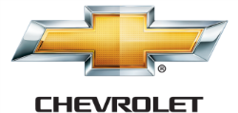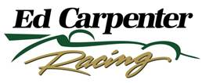 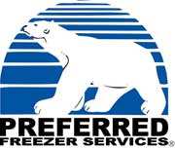

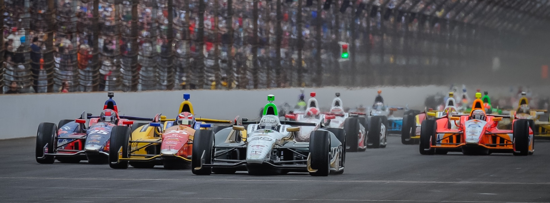

For Immediate Release Contact: Tom Blattler

317-525-5692

**ECR ANNOUNCES PARTNERSHIP WITH PREFERRED FREEZER SERVICES FOR JR HILDEBRAND-DRIVEN ENTRY IN INDY 500**

**2011 Rookie of the Year’s car will carry the famed Polar Bear Logo**

**ST. PETERSBURG, Fla.  (March 30, 2014)** – Ed Carpenter Racing today announced a partnership with Preferred Freezer Services for the team’s No. 21 Indianapolis 500-Mile Race entry driven by 2011 Indy 500 Rookie of the Year J.R. Hildebrand.

Last week, the ECR team announced Hildebrand will join team owner/driver Ed Carpenter in a two-car effort in the May 25 racing classic known as the “Greatest Spectacle in Racing.”

Hildebrand will drive the blue and white Preferred Freezer Services Chevrolet-powered IndyCar with the temperature controlled refrigerated warehouse storage and logistics company’s legendary polar bear logo as part of its dynamic look in this year’s 500.

“I am thrilled to team up with Ed Carpenter, a respected Indianapolis racer who has a passion for the Indy 500 and quality and JR Hildebrand, an experienced American driver, which is in perfect harmony with how we run our company,” commented  John Galiher, CEO of Preferred Freezer Services.

The Carpenter-Hildebrand combination currently will be the only All-American team entered in this year’s Indy 500.

-more-

-2-

“We feel teaming Carpenter and Hildebrand together for the world’s greatest auto racing event solidifies two strong contenders as one team with Preferred Freezer Services into this American driving lineup in the Indy 500, said Trut Edwards, President of Central Security. “Ed and JR have proven to be outstanding at the Indianapolis Motor Speedway and we are extremely excited to have them working together in the month of May.”

Hildebrand, 26, won the 2011 Indy 500 Rookie honors after placing second to Dan Wheldon and the California native captured the 2009 Indy Lights championship. Prior to the Indy Lights title, Hildebrand won the 2006 U.S. F2000 crown and the 2004 SCCA Formula Russell points.

“We are very pleased to announce our partnership with Preferred Freezer Services in conjunction with J.R.’s No. 21 ECR entry for this year’s 500-Mile Race,” said Carpenter, the 2013 Indy 500 pole winner. “This unique and innovative company is a leader in its field and gives Ed Carpenter Racing a new partner for the world’s biggest race. We believe the bright blue and white paint scheme and the legendary Polar Bear logo will be a fan favorite at the Indianapolis Motor Speedway this May, but will more importantly represent an innovative and successful partnership that will deliver tremendous value to our partners at Preferred Freezer Services.”

Hildebrand, now living in Boulder, Colo., is a three-time starter at the Indianapolis 500.

“I can’t express the excitement I have entering this year’s Indy 500 with Preferred Freezer Services and Ed Carpenter Racing,” said Hildebrand. “This new combination gives me a strong effort for the biggest race in the world and I look forward to working with Preferred Freezer Services. I can’t wait to see the popular Polar Bear on the side of the No. 21 Preferred Freezer Services Chevy this May.”

Practice for the 98th Indy 500 will begin Sunday, May 11, with qualification runs scheduled for May 17-18. The Indy 500 is set to start at noon on May 25.

# # #

**About Preferred Freezer Services:**

Preferred Freezer Services, headquartered in Chatham, New Jersey, is dedicated to designing, constructing and operating state-of-the-art warehouses throughout the United States and Asia. Preferred Freezer Services has grown from a single facility in 1989 to 35 locations and still growing. Preferred Freezer Services operates in locations throughout the United States with facilities in New York/New Jersey, California, Florida, Georgia, Illinois, Massachusetts, Pennsylvania, Texas,

**About Ed Carpenter Racing**

Owned by IndyCar Series driver Ed Carpenter, Ed Carpenter Racing was formed in 2011. Carpenter and the ECR/Fuzzy’s Vodka team won the 2012 season finale at Fontana, Calif., the MAVTV500, as well as the pole position at the 2013 Indianapolis 500. Mike Conway will drive the No. 20 at the road/street races in 2014 while Carpenter will handle the car in the six oval events including the Indy 500. J.R. Hildebrand will drive the No. 21 Preferred Freezer Services Chevrolet in the 98th Indy 500 for ECR. For more information, please visit [www.EdCarpenterRacing.com](https://mail.walkerracing.com/owa/redir.aspx?C=61rSHwiqUEuIdfcyu0pwI36UO9BWL9BIJJJgu31vUf3SmhMccV3qlzpBoAP-HQdzxg6lWH4mulY.&URL=http%3a%2f%2fwww.EdCarpenterRacing.com).