  

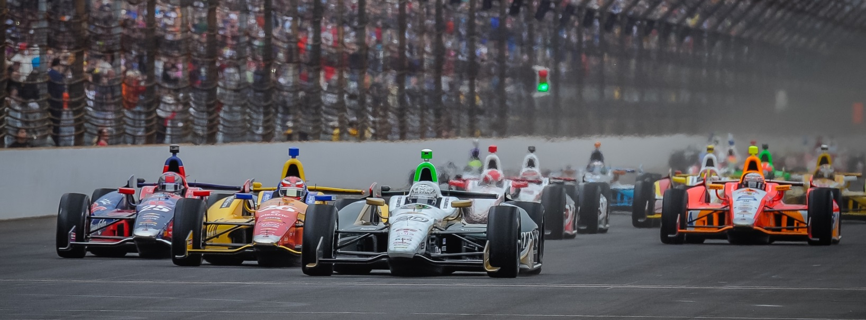

For Immediate Release Contact: Tom Blattler

317-525-5692

**WOW, 230 MPH FOR CARPENTER ON ‘FAST FRIDAY’ WITH**

**HILDEBRAND AT 229 AS QUALIFYING NEARS THIS WEEKEND**

**ECR All-American Duo Makes Excitement at IMS in Friday Action**

**INDIANAPOLIS (May 16, 2014)** – Ed Carpenter let the Indianapolis Motor Speedway garage area know Friday that the No. 20 Fuzzy’s Ultra Premium Vodka Chevrolet is going to be in the hunt for the pole position again this weekend after a stunning 230.522 mile per hour run.

The popular “Fast Friday” moniker held up to its name when Carpenter became the first driver since Scott Dixon in 2003 to top the 230 m.p.h. barrier in Indy 500 practice. Ed won the F.E. Harding Asphalt Corporation “Fast Friday” Lap of the Day and $10,000.

Several other drivers came close to 230 Friday including Carpenter’s ECR teammate J.R. Hildebrand, the 2011 Indy 500 runner-up. Hildebrand, in the No. 21 Preferred Freezer Services Chevrolet clocked a 229.384 m.p.h. reading for fourth on the speed charts behind Carpenter, Helio Castroneves and Marco Andretti.

Rain storms continued to play havoc with the practice sessions again Friday with the Verizon IndyCar Series teams running for less than an hour. But the big speed number excited the hardy crowd who braved the cold, windy and rainy conditions.

Carpenter, who was second fastest to Castroneves Thursday, recorded just eight laps, with the fifth being the 230 speed, while Hildebrand clocked his top speed on his fourth of eight laps.

“You can definitely feel the speed difference with the added horsepower now,” said Carpenter, the 2013 Indy 500 pole winner. “They never give us the horsepower numbers. It’s a graph to show what they have added for qualifying trim. It is fun when you are going fast.

-more-

-2-

“It looks like we have better competition from Honda this year with speed than last year. I have been fortunate to be in a tow the last two days here, so we’ll have to see how things line up on Saturday for qualifying. Everything is determined by the weather. If we run with the weather we had last year in qualifying, I think you could see a 232 or 233. But it has been colder and that means more downforce with cars so far.  I think both of our cars are pretty fast right now.  Now we’ll have to see how everything goes over the weekend.”

Hildebrand, who was second fastest on Wednesday in practice, is happy to be with ECR squad and team up with a veteran like Carpenter, a former 500-mile race winner (Fontana, 2012).

“We are happy with what the Chevy boys are giving us right now,” said Hildebrand. “With so many cars on track, it is hard to see where everyone shakes out right now. We felt good about our run today but everyone is getting a tow right now. We are glad we ran on Thursday to get a feel with the car being trimmed out a little. Then you get the extra horsepower for qualifying too. I think we have something good to work with as we head into the weekend for the two days of qualifying. I feel really fortunate to be with ECR and work with Ed in a two-car team. Both of us really haven’t had that type of opportunity in a long time. We have a similar feel for the car right now and I really help us.  It is much easier for the team because everyone to work to the same goal and settings.  We would have liked to have run more today to collect more data.  But it rained again and we’ll have to be ready for Saturday now.”

Qualifying gets underway Saturday at 11 a.m. and runs until 5:50 p.m. for spots in the 33-driver field. On Sunday, the pole position and the entire field will be determined including the exciting Fast Nine Shootout from 1-3 p.m. Carpenter captured the 2013 pole in a late run in the Fast Nine Shootout.

# # #

