

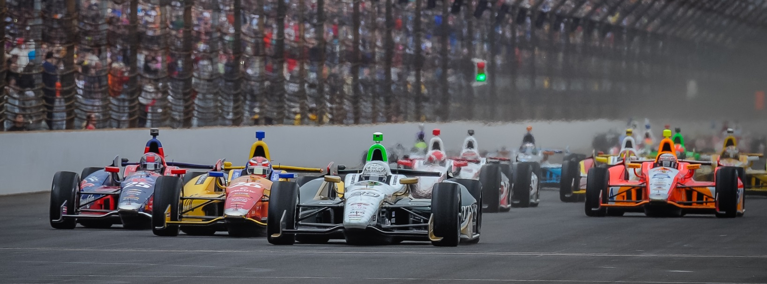

For Immediate Release Contact: Tom Blattler

317-525-5692

**CARPENTER’S STRONG RUN ENDS QUICKLY SUNDAY IN INDY 500;**

**TURN 1 CRASH WRECKS FUZZY’S CHEVY DRIVER DAY**

**2014 Indy 500 Pole Winner Knocked Out Running 2nd**

**INDIANAPOLIS (May 25, 2014)** – Ed Carpenter’s day ended suddenly in turn one Sunday in the 98th running of the Indianapolis 500-Mile Race. And he wasn’t happy about it.

The two-time consecutive Indy 500 pole winner looked to be position to fight for his first Indy 500 title on lap 175 when his No. 20 Fuzzy’s Ultra Premium Vodka Chevrolet was struck from the left side by James Hinchcliffe’s car and both drivers’ mounts slammed into the outside barrier.

Carpenter, the only team owner/driver in the Verizon IndyCar Series, fought his way back into contention after a tire issue in the middle of the race slid him back to 18th. A quick pit stop on lap 145 and a wing adjustment helped Carpenter’s Dallara chassis return to battle with the leaders.

Then, on the lap 175 restart, eventual winner Ryan Hunter-Reay took the lead over Carpenter into turn one as Townsend Bell went high and Hinchcliffe tried to go low. Three wide in turn one just didn’t work this time and Carpenter and Hinchcliffe made contact. Bell luckily made it out of the skirmish and motored on.

Needless to say, Carpenter wasn’t happy with Hinchcliffe’s actions in the mishap as the 33-year-old racer looked to be in position to challenge Hunter-Reay for the win. Unfortunately, the Butler University graduate had to settle for 27th on the scoring pylon at the world’s most famous racing facility at the end of the day.

Carpenter’s teammate J.R. Hildebrand drove the No. 21 Preferred Freezer Services Chevrolet to tenth Sunday at Indy after the California native run as high as third in the 200-lap classic.

-more-

-2-

“Hinch (James Hinchcliffe) tried to make three wide in turn one with 25 laps to go,” said Carpenter after the incident. “Not a smart move.  It wrecked both of our races. It wasn’t a green-white-checkered situation. Of all of the guys out there, I wouldn’t have thought it would be Hinch. I am pretty good friends with him and those guys at Andretti. I think he just didn’t use his head right then.

“I totally believe we were right in the mix with Ryan (Hunter-Reay), Helio (Castroneves) and Marco (Andretti). I was running with Ryan right then and we had swapped the lead a few times.  We got a little fortunate in the middle of the race when we blistered a right rear tire and had to pit earlier than we wanted. We were able to hold off the leaders then when the yellow came out, I was back up front and the car felt good. We were just trying to figure out how to set a guy up for the last lap of the race. It just stinks.”

Today was Carpenter’s 11th Indy 500 start and the second straight year he had started from the pole position. Last year, Ed led the most laps in the race at 37 and today he led 26 laps.

The Verizon IndyCar Series now moves to the Motor City of Detroit and the Chevrolet “Duals In Detroit” doubleheader at the streets of Belle Isle, the island just northeast of downtown. The 2013 Detroit race winner Mike Conway, also the 2014 Long Beach champion, will be back to defend his title in the No. 20 Fuzzy’s Ultra Premium Vodka Chevrolet.

Both main events (Saturday and Sunday) at Belle Isle will start at 3:30 p.m. EDT and will be shown on ABC-TV.

# # #

