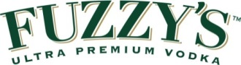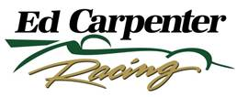

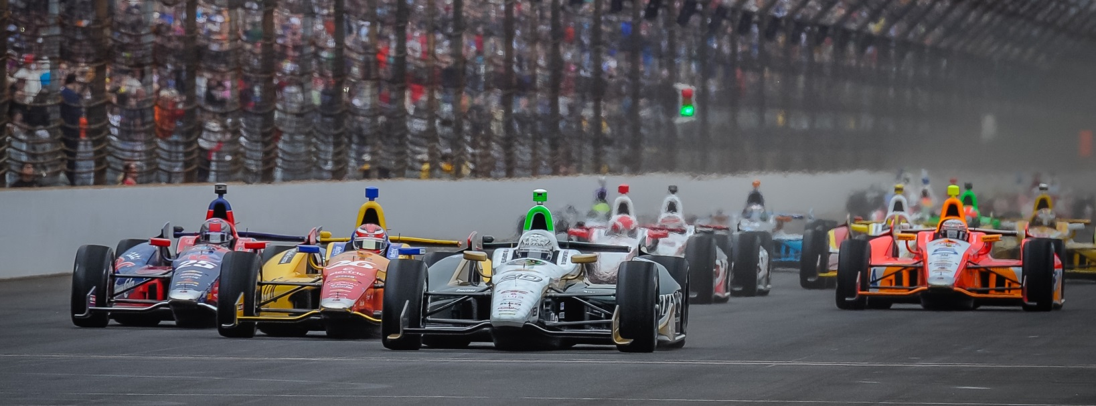

For Immediate Release Contact: Tom Blattler

317-525-5692

**ED CARPENTER TAKES 9TH SUNDAY AT MILWAUKEE MILE**

**AS HE FIGHTS HIS WAY BACK FROM 16TH IN 250-LAPPER**

**ECR/Fuzzy’s Team Tries Longer Fuel Stint Early in the Race**

**WEST ALLIS, Wis. (August 17, 2014)** – Ed Carpenter felt his No. 20 Fuzzy’s Ultra Premium Vodka Chevrolet would be able to compete with the leaders in Sunday’s ABC Supply Wisconsin 250 at the famed Milwaukee Mile.

And the Texas race winner looked to be a contender in the first 50 laps Sunday.

Unfortunately, that strategy ended after the first pit stop in the 16th stop of the 18-race Verizon IndyCar Series and Carpenter fought his way back to ninth at the finish.

Carpenter’s team attempted to run a longer fuel stint than the leaders and that decision ended up hurting the series’ only team owner/driver Sunday. Carpenter ran in the top seven for the first 55 laps.

In fact, he led the race from lap 60 to 62 as the Butler University graduate attempted to stretch his fuel mileage. But, in taking the fuel strategy plan, Carpenter’s used tires hurt his lap times. By the time Ed returned to the one-mile oval after his first pit stop on lap 63 he had lost a considerable number of positions. He had to battle from 16th to ninth.

Outstanding pit stops by the Ed Carpenter Racing/Fuzzy’s Vodka crew helped Carpenter in his charge back to a top ten placing Sunday.

Chevy driver and pole winner Will Power took the win Sunday followed by other Chevy drivers Juan Pablo Montoya, Tony Kanaan and Scott Dixon.

-more-

-2-

“Track position is everything here at Milwaukee,” said Carpenter, who shares the No. 20 machine with Mike Conway in the IndyCar Series. “The Fuzzy’s Chevy felt good in the first stint but we might have stayed on the older tires too long, at least compared to the leaders.  And we ended up way too fall back when we came out of the pits. The crew guys did some great pit stops today and we were able to fight back to a top ten. I thought we might have a top five car today. It was very difficult to pass and the track changed a lot from Saturday with wind.  So turns three and fourth were difficult today. We will just take ninth and move onto Sonoma and Fontana now.”

Conway returns to the cockpit of the Fuzzy’s Vodka Chevrolet next weekend (Aug. 23-24) at the picturesque road circuit at Sonoma Raceway, north of San Francisco. The two-time 2014 race winner will seek his third victory of the year at a track he has placed on the podium in the past.

Carpenter will drive the No. 20 machine in the season finale on Aug. 30 at the Auto Club Speedway in Fontana, Calif. In his last two appearances at the two-mile oval in Southern California, he won the race (2012) and placed second (2013).

# # #

