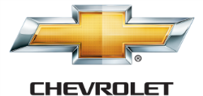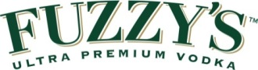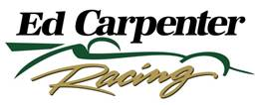

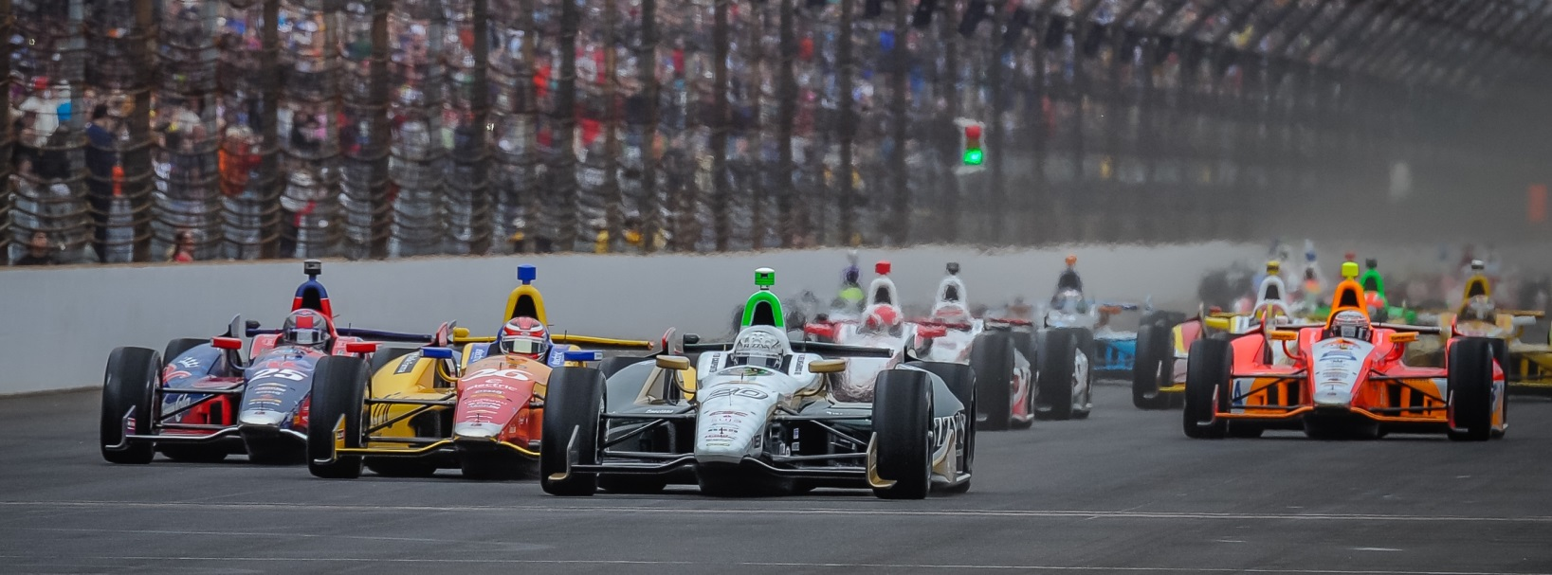

For Immediate Release Contact: Tom Blattler

317-525-5692

**ED CARPENTER BACK AT AUTO CLUB SPEEDWAY SATURDAY TO PLAY FOR THE SPOILER ROLE IN INDYCAR SERIES TITLE RACE**

**Butler Grad Returns after 1st and 2nd Place Runs at Fontana**

**FONTANA, Calif. (August 26, 2014)** – The last thing the Verizon IndyCar Series title contenders want to see in their mirrors Saturday night in the MAVTV 500 season finale is the green, white and gold machine of Ed Carpenter.

As point hopefuls Will Power, Helio Castroneves, Simon Pagenaud, Ryan Hunter-Reay and Scott Dixon look to score the prestigious series crown, they also know that Carpenter poses the biggest challenge to them in the 500-mile contest at Auto Club Speedway.

The Butler University marketing grad might be the only team owner amongst the series’ driver lineup but the Indianapolis 500 pole winner is a favorite to win the 250-lapper too.

Carpenter has put his popular No. 20 Fuzzy’s Ultra Premium Vodka Chevrolet in the Fuzzy’s Victory Lane at Fontana each of the next two years including scoring his team’s first win in 2012 and finishing a close second to Power last year.

Now, Carpenter comes to Fontana on a mission too. Saturday’s 2014 series wrap-up race will be his final with his Ed Carpenter Racing logo.

Next season, Carpenter will partner with Sarah Fisher and Wink Hartman to field cars from the newly-formed CFH Racing in Speedway, Ind. So Ed would like to finish the ECR campaign with another race win.

“To be honest, winning at Fontana would be a tremendous way to close out the run at Ed Carpenter Racing,” said Carpenter, this year’s Firestone 600 winner at Texas Motor Speedway. “I am very much looking forward to the future but winning the last ECR race has really been on my mind for the last month once we announced the new team.”

-more-

-2-

This Saturday’s race at Fontana will be Carpenter’s sixth event in 2014 after he made a unique decision to split the driving chores with road racing specialist Mike Conway in the Fuzzy’s Vodka Chevy.

Carpenter has only driven five oval tracks this year with Conway piloting the ECR team’s car in the 12 street and road contests. But the spilt duties have produced three wins and one pole position (Indy 500).

“Sure, I could have race in all 18 events this year,” said Carpenter, who came from the oval tracks of USAC sprint cars and midgets. “But my partners and I felt we had a better chance to race for wins if we split up the driving between Mike and myself. It’s worked out pretty well.”

Conway has scored victories in the streets of Long Beach and Toronto while Carpenter won the Indy 500 pole and the Texas oval race. With the two drivers’ current points, they rank seventh in the Verizon IndyCar Series entrant standings.

“And I think if we finished at Indy and Pocono where we were running before trouble hit us, we would be in the top-five right now,” said Carpenter. “That was our goal at the beginning of the year.”

But the year is almost over for the Verizon IndyCar Series drivers and Carpenter could be the spoiler when it comes down to the checkered flag Saturday night at Auto Club Speedway.

One has to figure the leaders do not want to see Carpenter in their mirrors and closing on them with laps still remaining in the MAVTV 500.

The MAVTV500 will be televised Saturday night live on NBC Sports Network beginning at 6 p.m. PDT (9 p.m. EDT). The green flag will drop at 7:20 p.m. PDT (10:20 p.m. EDT). The IndyCar Radio Network also will broadcast the race live through its affiliates as well as Sirius 2013, XM 209 and [www.indycar.com](http://www.indycar.com).

# # #

