For Immediate Release
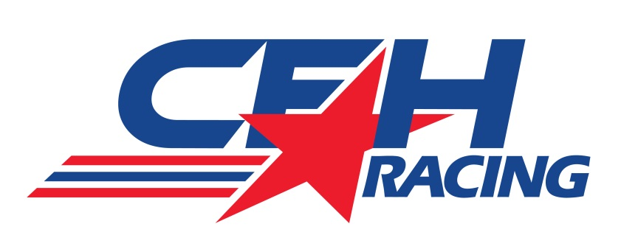

CFH RACING TO UTILIZE CHEVROLET ENGINES
AND AERO KITS IN 2015 VERIZON INDYCAR SERIES

Newly-merged Team to Sport the Famed Bowtie Logo with Two Cars

INDIANAPOLIS (Sept. 17, 2014) – Newly-formed CFH Racing and Chevrolet announced today that the famed automobile manufacturer will provide engines and aero kits for the team’s entries in the Verizon IndyCar Series for the 2015 season.

CFH Racing, co-owned by Ed Carpenter, Sarah Fisher and Wink Hartman, is scheduled to field two cars in the 2015 Verizon IndyCar Series with the same engines that have guided Chevrolet to three consecutive IndyCar Series manufacturer championships.

CFH Racing announced its formation on Aug. 16 with the merger of Ed Carpenter Racing and Sarah Fisher Hartman Racing for the 2015 IndyCar Series. The team will be based at 1255 Main St. in Speedway, Ind., a few blocks from the legendary Indianapolis Motor Speedway.

Chevrolet, a racing leader for over 100 years, returned to IndyCar competition in 2012 with the Chevrolet twin-turbo 2.2 liter V6 engine featuring an aluminum block and cylinder heads, direct injection and utilizing E85 fuel. Drivers powered by the Chevy IndyCar V6 have scored 33 race wins in the three seasons that resulted in Chevrolet winning three consecutive series' manufacturers championships. Additionally, the Bowtie Brand powered the 2012 and 2014 driver's champions and claimed victory in the 2013 Indianapolis 500. Chevrolet will debut its new Verizon IndyCar Series body kit in 2015.

The current Chevrolet V6 Twin Turbo IndyCar engine was introduced in 2012 and has scored 33 wins in the last three seasons. Chevrolet fielded ten engines in the 18-race IndyCar Series in 2014.

“We are pleased that the newly formed CFH Racing will compete with Chevrolet’s twin-turbo V6 in the Verizon IndyCar Series beginning in 2015,” said Jim Campbell, Chevrolet’s vice president of performance vehicles and motorsports. “Adding Josef Newgarden to the Chevrolet IndyCar V6 driver roster, and Sarah Fisher and Wink Hartman along with Ed Carpenter to our key partners in IndyCar is exciting for Chevrolet. Ed's team has produced tremendous results the last three seasons, and we will be thrilled to see the CFH Racing Chevy-powered cars on the track in 2015.”

Carpenter’s current team, Ed Carpenter Racing, debuted in 2012 with the Chevrolet V6 engine and has recorded four Verizon IndyCar Series victories, two by Carpenter and two by Mike Conway. Carpenter’s No. 20 Fuzzy’s Ultra Premium Vodka Chevrolet has also captured the 2013 and 2014 Indianapolis 500 pole position.

-more-
-2-

“I am very proud that CFH Racing will be powered by Team Chevy for the 2015 season,” said Carpenter. “Team Chevy has delivered for ECR over the past three years, and I know that our new combination of CFH Racing and Chevrolet will continue to put us in a great position moving forward. We are totally confident in their product, and cannot wait to debut the Chevrolet Aero Kit starting in 2015.”

Sarah Fisher Hartman Racing was established in 2008 with Fisher driving its lone Verizon IndyCar Series entry. Successful businessman Wink Hartman became a co-owner of the Indianapolis-based squad in 2011.

Carpenter drove the Sarah Fisher Hartman Racing machine to its lone Verizon IndyCar Series victory when he nipped Dario Franchitti in a dramatic duel at Kentucky Speedway in 2011.

CFH Racing recently announced the signing of Newgarden for the 2015 season. The former Indy Lights champion has driven for Sarah Fisher Hartman Racing the past three years in the Verizon IndyCar Series. He finished second this year at Iowa Speedway.
“Being a part of the Chevy family in the past, I am looking forward to rejoining their organization,” said Fisher, the first female driver to win a Verizon IndyCar Series pole position (2002 at Kentucky Speedway). “The decision to partner CFH Racing with Chevrolet was the first of many that we will make together as a team. The process was sincerely a group effort and encourages all of us as to how we will work as a team.

“I have been extremely grateful for the partner that Honda has been in my career and to SFHR. We are thankful for their ongoing support of the Verizon IndyCar Series”.

Hartman is excited to bring Chevrolet to the new CFH Racing organization next year.

"CFH Racing continues to develop into a top tier team with a contract with Chevy,” said Hartman. “The team is excited to start a strong relationship with Chevy going into the 2015 Verizon IndyCar Series.”

The CFH Racing Chevrolet partnership will debut at the 2015 season opener.

Direct injection and turbo-charging are fundamental elements of the Verizon IndyCar engine package, and both are key technologies in several powerful and fuel-efficient Chevrolet production cars today. The Chevrolet Cruze and America’s favorite sports car, the Camaro, are just two examples of key Chevrolet products powered with advanced engine technology, offering fun to drive performance and outstanding fuel efficiency.

# # #

ABOUT CHEVROLET: Founded in 1911 in Detroit, Chevrolet is now one of the world's largest car brands, doing business in more than 140 countries and selling more than 4.9 million cars and trucks a year. Chevrolet provides customers with fuel-efficient vehicles that feature spirited performance, expressive design, and high quality. More information on Chevrolet models can be found at www.chevrolet.com.

Contacts: Tom Blattler, ECR, (317) 525-5692, tomblattler@earthlink.net
Becca Bornhorst, SFHR, (614) 620-1288, becca@grand-solutions.net Judy Kouba Dominick, Chevrolet Racing, (317) 408-1049, jkdracer@aol.com

