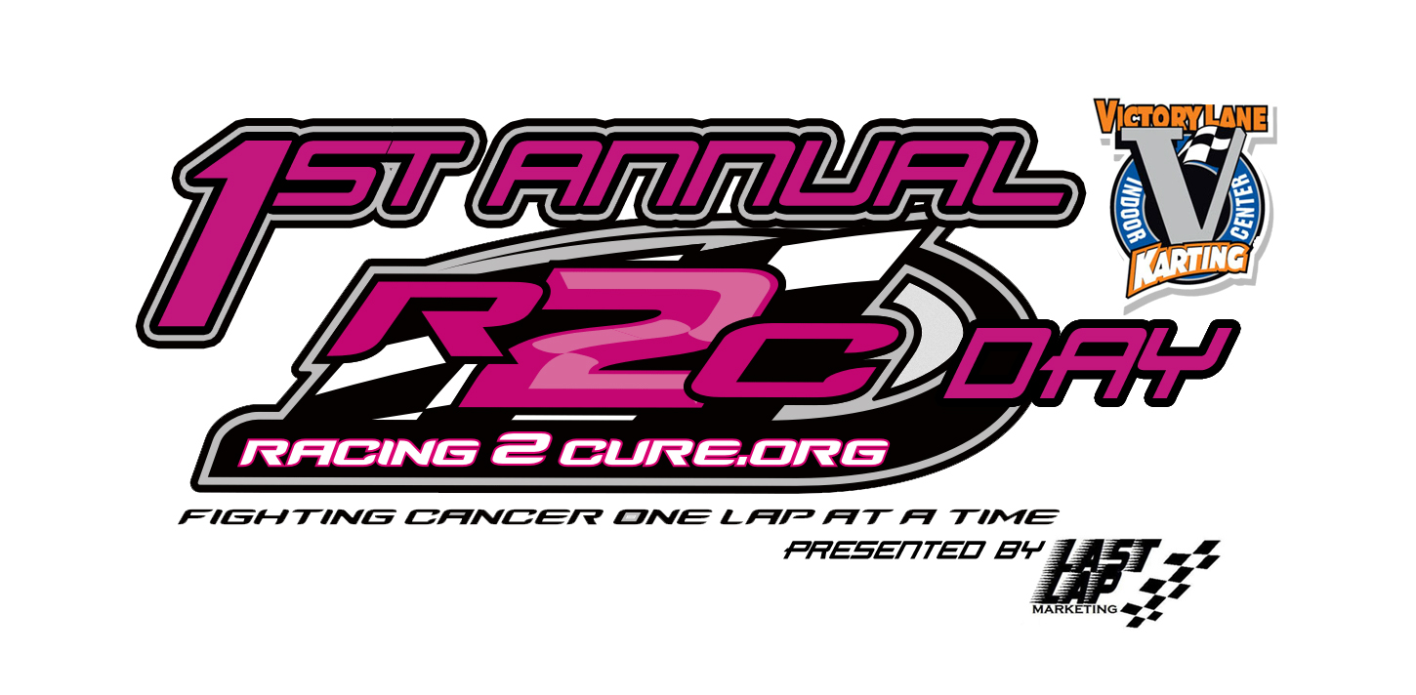Bradley Carpenter
Last Lap Marketing, Owner
704-860-6803
brad@lastlapmarketing.com

FOR IMMEDIATE RELEASE

1st Annual Racing 2 Cure Day at Victory Lane Karting Fuels Ongoing Fight Against Cancer

CHARLOTTE, NC (March 19, 2013) - Racing 2 Cure, Victory Lane Karting (VLK), and Last Lap Marketing are excited to announce that the 1st Annual Racing 2 Cure Day at Victory Lane Karting presented by Last Lap Marketing will occur on April 5 to help continue raising funds for the fight against cancer. The event will take place at VLK from 11am till closing, midnight.

For every race that is purchased on April 5, $5 will go to Racing 2 Cure. In addition, VLK will suspend normal pricing and will have the following price bracket: 1 race $20, 2 races $40, 3 races $50, and 4 races for $65. Throughout the evening portion of the event, 7-10PM, several different activities will be occurring in which the community can take part in. There will be raffles, driver autographs, picture opportunities; the Racing 2 Cure Bandolero race car will be present, and more! Further details on what will be happening during the event will be located on Last Lap Marketing’s website, www.lastlapmarketing.com.

Racing 2 Cure is a local Charlotte Metro area charity aimed at helping the human side of cancer by providing assistant to pay for utility bills, car payments, rent, day care, etc. The foundation was founded in 2011 by Hunter Stewart, whose mother, Alycia Stewart, is a two time Breast Cancer survivor and is currently undergoing several surgeries, Chemotherapy, and radiation treatments. In 2011, the program launched an online fundraising website which allows drivers from the dirt to asphalt to register to help Racing 2 Cure raise funds as well as help support their racing programs. Drivers are allowed to choose from several options on how their fan donations will be split between Racing 2 Cure and the race team. The funding that goes back to the team, allows the charity to continue to get donations by allowing drivers to fight cancer one lap at a time.

"Racing 2 Cure is very grateful for the support and organization of this event by Brad Carpenter, his team at Last Lap Marketing, and the assist of Racing 2 Cure driver Andrew Mulhearn. Events like this go a long way to not only raise funds but to also help promote Racing 2 Cure's mission of helping families fighting cancer,” Alyica Stewart said. “What Last Lap Marketing has been able to organize is amazing! On behalf of the Racing 2 Cure Team and the families that receive help from R2C, we would like to thank Last Lap Marketing and its founder Brad Carpenter for all of their time and hard work! Furthermore, thank you to the staff at Victory Lane Karting for their hard work in making sure the racing side of the event goes smoothly."

Last Lap Marketing has been working with Racing 2 Cure for just over a year and is excited to take the relationship to a new level. Being an official promoter ambassador for Racing 2 Cure, Last Lap Marketing has brought on more than fifteen drivers to the program as well as having one of its clients, Garrett Marchant, as a Racing 2 Cure Ambassador.

“This event is something that I have looked forward putting together ever since we started our partnership with Racing 2 Cure,” said Last Lap Marketing Owner, Bradley Carpenter. “Everyone at Victory Lane Karting and Racing 2 Cure have made planning this event an ease and cannot wait to see how much is raised for such a deserving charity. Our goal and hope is to host this event each year and continue to make it bigger and better!”

-35-

Victory Lane Karting
2330 Tipton Dr. Ste. 100
Charlotte, NC 28206
Phone: 704-377-FAST

RACING 2 CURE began as a simple act of then 7-year old Hunter Stewart. Hunter was just starting his off-road racing career when he received troubling news. Just a few weeks before his first-ever race, his Mom at just 34-years old, was diagnosed with Breast Cancer. In order to maintain a positive focus, the family decided to continue racing. After attending an event held by Susan G. Komen for the Cure (R), Hunter was inspired to take action. He carried the Komen logo on his race truck, wore pink shoe laces, and gave one-weeks’ worth of his allowance for every race lap he completed. This one-race effort inspired others to take action. Hunter's story was largely covered by the media and recognized by public officials, including a guest appearance on the Ellen DeGeneres Show.

After several treatments Hunter's Mom (Alycia) went into remission (for three years.) Unfortunately Alycia was diagnosed again with Breast Cancer. She is currently in remission from her second fight with cancer. Alycia's cancer has taught the Stewart family the first hand hardships that Cancer brings to families. It was ‘families’ in need while undergoing treatment that inspired the formation of Racing 2 Cure Non-Profit Organization.

Victory Lane Karting is an indoor conference center, race facility, and entertainment venue located in the heart of Charlotte, NC. Our 1/3 mile road course is the fastest in the Carolinas and one of the fastest in the nation. Sodi Honda top-of-the-line racing karts challenge any driver with top speeds of 45 mph at 2” off of the ground. Doesn't sound fast? Come experience it for yourself!

Victory Lane Karting can host any type of event you are looking for, from a small group of 8 to a large group of 1000. If it's a teambuilding exercise for your company, a children’s birthday party, a product launch or just some friends looking for something exciting and different to do, VLK is YOUR PLACE TO RACE as well as a top-notch facility for any kind of event. Please check out the rest of our website and call us at 704-377-FAST (3278) with any questions.

