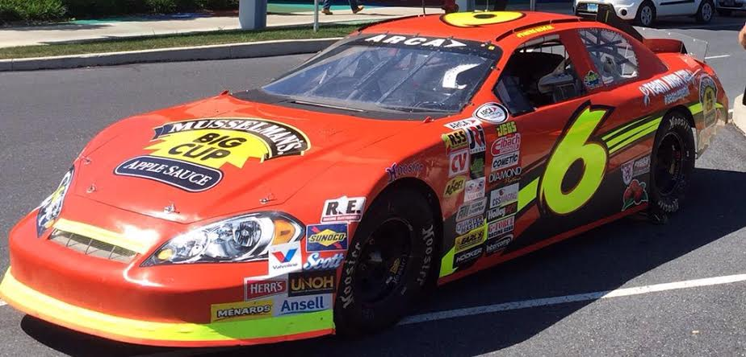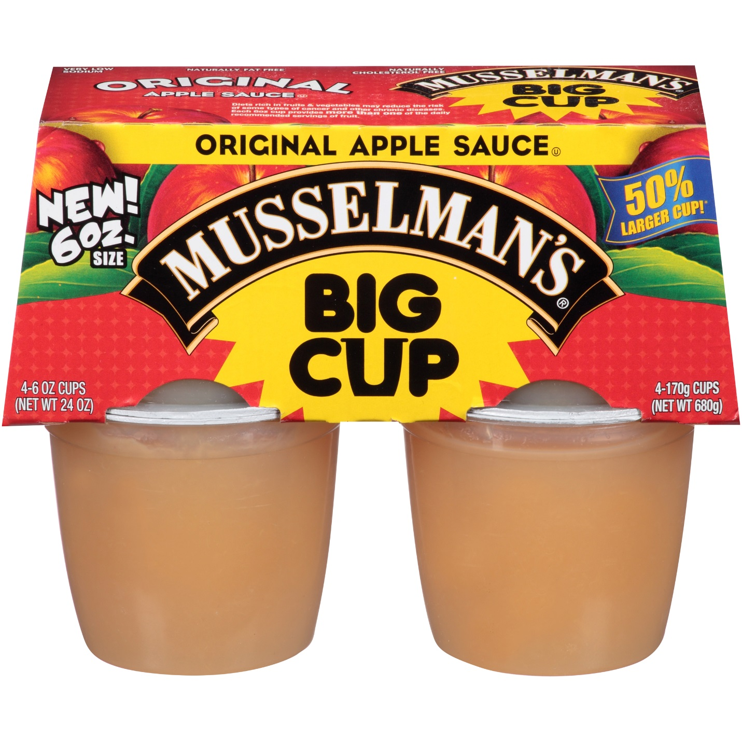

**Musselman’s increases sponsorship of ARCA championship contender Josh Williams**

(CONCORD, N.C. - August 27, 2015) - Knouse Foods Inc. and its Musselman’s Applesauce brand have increased their partnership with ARCA Racing Series presented by Menards championship contender Josh Williams.

Musselman’s BIG CUP brand first joined Josh Williams Motorsports (JWM) in June of this year and the partnership has grown since day one.

“Musselman’s is excited to extend our partnership with Josh Williams and his special campaign - Team Anya Cale (#BeatLeukemia),” said Kevin Blacker, Assistant Director of Marketing for Musselman’s.

“Josh and his family-owned team have fit right in with our Musselman’s family and we’ve had the pleasure of getting to know each other on a personal level. With their visits to our plants and other outreach events, including his nationwide Children’s Hospital Tours, Josh Williams is a perfect fit to represent our brand both on and off the track.”

The increased partnership will showcase Musselman’s BIG CUP brand as the primary sponsor at the upcoming events at Kentucky Speedway and Kansas Speedway to close out the ARCA Racing Series season.

“Our excitement grows with each race as we root Josh on to victory lane, and on to the ARCA Racing Series championship this year,” said Kevin.

The partnership will also increase its current associate package for the DuQuoin State Fairgrounds and Salem Speedway events.

“I can’t thank Musselman’s enough for their support this year,” said Williams. “It is incredible to represent such a great brand and great group of people.

“All the folks at Musselman’s have been such great supporters of our program both on and off the track. I look forward to this championship run with them and look forward to putting their Musselman’s Chevy in victory lane real soon.”

Williams is currently second in ARCA Racing Series championship standings, 150 points from first with four races remaining in 2015. With the championship in sight, Williams and his #LittleTeamThatCan continue to roll on with a great partner along for the ride.

Musselman’s BIG CUP is the only 6-oz size cup in the applesauce category and is targeted to health-conscious active teens and adults with larger appetites.

**About Musselman’s:** Musselman’s was founded in Biglerville, Penn. in 1907 by Christian and Emma Musselman. We have been proud to produce your family’s favorite Apple Sauce and Apple Juice for over 100 years. For more information about Musselman’s follow them on twitter @Musselmansapple or visit their website at <http://musselmans.com>.

Josh Williams Motorsports is a Concord, North Carolina-based ARCA Racing Series presented by Menards team. With a family tradition of racing and mentoring programs, JWM excels in driver development programs and brand marketing.

Follow Josh Williams Motorsports and the #LittleTeamThatCan @Josh6Williams on Twitter and visit their website at www.JoshWMotorsports.com or like us on Facebook JWmotorsports.

CONTACT

Meghan Henriques

704-787-2031

MeghanDEMarketing@Gmail.com