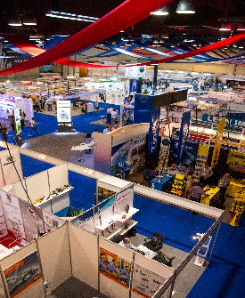
PRESS RELEASE
The 2016 LATIN AUTO PARTS EXPO was a roaring success! The third edition of the show took place June 15-17th at the ATLAPA Convention Center in Panama City, Republic of Panama. A record-breaking 370 exhibitors from 21 countries displayed their products & services at the show and approximately 3,850 visitors from 56 countries attended. Panama, Venezuela, Colombia, Costa Rica and Ecuador were named the top five visiting countries, respectively.
The United States Department of Commerce granted Trade Fair Certification to the LATIN AUTO PARTS EXPO for the second consecutive year. Through this certification, the Commercial Service Department of Commerce recognized the professionalism of the organizer and allowed the Expo to organize a pavilion for American companies. In addition, the Department of Commerce recommended the event as an excellent opportunity to present American products and services.
The Inaugural Ceremony and Party was held on the first day of the show at the Teatro La Huaca. The ceremony consisted of a ribbon-cutting and a live musical performance by the Sociedad Anonima Orchestra. Complimentary cocktails and appetizers were also enjoyed by attendees. All exhibitors participating for the third consecutive year were presented with plaques on stage recognizing their companies’ loyalty to the expo.
The Educational Conferences took place on the second day of the exhibition at the Salon Portobello. The Conferences featured industry leaders who discussed various topics prevalent in the auto parts industry, such as “Automotive Diagnostics: Trends and Challenges towards 2020”, “Evolution of Timing Systems”, and “Inventory Services and Solutions for Latin America”, to name a few.
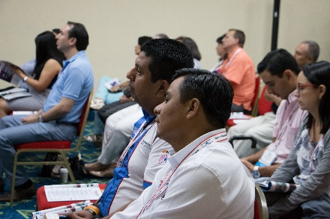
The Conference Speakers included: Mr. Roy Martinez, (Electronic Engineer, Autoland Scientech USA, Inc.), Mr. Frank Flores (Aftermarket Sales Manager, Mitsubishi Turbocharger), Mr. Juan Manriquez (Product Technician, Cloyes Gears and Products, Inc.), Mr. Hernando Gordils (International Business Development Manager, NAPA Auto & Truck Parts), Mr. Teolindo Vall (VP of North America Sales, TVA Automotive, Inc.), and Mr. Jorge Luis Carbonell (President & CEO, Kashima System).
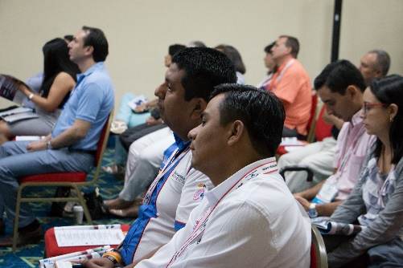
Two Apple © iPad Minis were raffled among the conference attendees.

“We think Panama has been a great location for the show because it is strategically located in the middle of Latin America and it's a beautiful country too. We've had a great experience at the expo and we really appreciate all the attention that the staff has given to our company,” stated exhibitor Gustavo Mok of ASINSA (Grupo Asia Internacional S.A.).
The LATIN AUTO PARTS EXPO connects leading manufacturers and distributors of the auto parts industry with vetted, qualified buyers from Latin America and the Caribbean creating and growing the distribution of their products in the region. The objective of the trade show is to facilitate long-term commercial relationships between suppliers and buyers.

To reserve your booth or register FREE as a visitor at the 2017 LATIN AUTO PARTS EXPO, please visit www.latinpartsexpo.com, call +1(786)293-5186 or email alexandra@latinpartsexpo.com.

