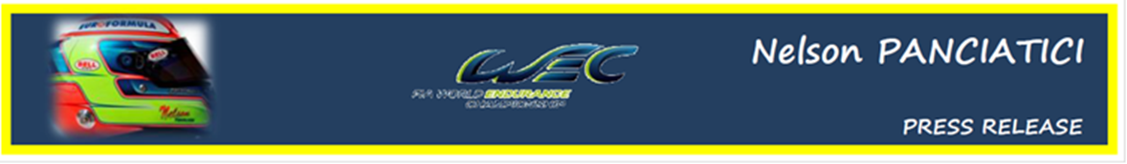
FIA WORLD ENDURANCE CHAMPIONSHIP – ROUND 5:
6 HOURS OF SAO PAULO (14 and 15 September 2012)

NELSON PANCIATICI GIVES US PERFORMANCE

The G-DRIVE RACING BY SIGNATECH team and their drivers discovered the famous Jose Carlos Pace circuit in Interlagos, Brazil and produced some fine results during practice. Nelson Panciatici made the best time in the last session. For the qualifiers, he missed pole position by just over one tenth of a second with the third best time.
Hope for victory was therefore warranted. Unfortunately, Nelson PANCIATICI took a rear collision in the warm-up lap which forced him to return to the stands to change the rear bonnet. He got back into the race with 3 laps to catch up. Nelson and his co-drivers, Pierre RAGUES and Roman RUSINOV fought valiantly to get back into fourth place before they were once again delayed with a ruptured disc brake and lost more than four minutes. Nelson PANCIATICI threw himself into a desperate chase and crossed the line in a very disappointing seventh place considering the performance put on by the full ORECA 03 NISSAN #26 team. A small compensation for Nelson, he will remain overall, for this weekend, the best performer of a lap in the LMP2 category.
Nelson: "We are disappointed with the final result because we were certainly one of the most consistent teams and our Oreca 03 Nissan was among the best tuned. Damien, our engineer, gave us an almost perfect car and it was easy to drive. Even after the incident at the start we were still in with a fight for the podium, it's a real shame but the positive side is that we are sure today that our team driver package is able to aim for victory whatever the track, and that's important in a category as competitive as LMP2. It bodes well for the rest of the championship. Personally, I learnt a lot again this weekend and I'm beginning to feel the traffic better, my last two relays were good and consistent. I had a great time in full attack mode from the beginning to end of my relays. When we drive single-seaters we think that you have to drive carefully in endurance, I can assure you that it's far from that!"
Philippe Sinault: "We were fighting for fifth place in the end. It's satisfying to see that we were still in the running all along the weekend and among the liveliest on the track. The car was very high-performance, without the incident in the warm-up with Liuzzi who came and hit us from behind and destroyed a part of the car. That stupid accident deprived us of the podium, if not more. The car was producing better and better results as the temperature fell toward the end of the race. Pierre had done his job by mid-race, Roman drove at a very high pace, and Nelson even signed the best time of the race one hour from the end. We are disappointed of course because success really was within our reach. We will now take the races as they come and try to make our mark with a victory. Since Silverstone we've have really stepped up in terms of performance. We definitely have one of the best driver teams and the teamwork is paying off. Bahrain, Mount Fuji and Shanghai will definitely be the stage for a lot of fights on the track. Despite the incidents this weekend, I am still confident for the coming races and I really hope that we take a victory between now and the end of the season."
The next meeting, the 6 Hours of Bahrain, will take place on September 28 and 29 on the international circuit of Sakhir which usually hosts the Formula 1.

For more information on Nelson PANCIATICI, please visit www.nelsonpancia.fr
Join Nelson's Fan Club on Facebook!

