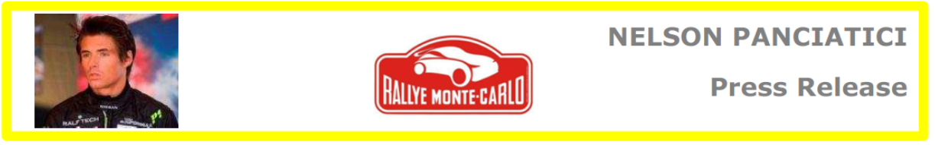
A NEARLY HAPPY NELSON PANCIATICI

He dominated the R2 category from the very first leg in the Ardèches, behind the wheel of his Renault Twingo RS R2 Evo, prepared to perfection by the Gliese team. Nelson Panciatici was just beginning to manage his two minute lead when black ice caught him out in the last Special Stage of the second leg of a snowy Monte Carlo rally. He still kept his lead though in the R2 category.
For the third leg, the choice of tyres turned out to be vital but, well informed by his safety note crew, Mathieu Arzeno and Florien Haut Labourdette, Nelson took on the famous Sisteron stage with the correct tyres. Unfortunately the gearstick snapped 10 kilometres from the finishing line and slowed him down considerably. He lost the lead in the R2 category by 48 seconds.
Now in second place before the final, Nelson Panciatici had no choice but to attack despite the Dantean conditions. Unfortunately Nelson was caught out in the downhill to the Turini, the same as Latvala, Novikov and even Hanninen who all came off in the same place. Race over but a quality performance for this young track guy who had never driven on studded tyres!
Nelson is definitely disappointed to abandon so close to the end but he wants to focus on the positive side: "I have never done anything so difficult since I started racing but what a pleasure to drive on snow. I had a great time all the way except in the Turini where it was about survival! I was getting on well but I got stupidly caught out even though we had slowed the pace after the pass and there were only 4 or 5 more bends before the dry section! That's what racing is about, we tried and we lost but I don't regret any of it. I do one or two rallies a year and I want to do them well. My thanks go to my team and my partners without forgetting the spectators who encouraged us all the way, it was heart-warming!"
René Padovani, his co-driver, was just as enthusiastic: "Nelson really surprised me on the snow. He is a true rally man now. We really went for it on the snowy downhill of the Burzet to make up time, we even made the second fastest time in two-wheel drive when everyone was still in the running and equal tyre conditions! We were managing our time when the gearstick broke, after that we had no choice but to attack, we were climbing back into the R2 lead too, shame. We received an incredible amount of congratulations on the social networks, I think we must have pleased the spectators."
To achieve these great performances they certainly needed a good team like Gliese, a good car like the Twingo RS R2 évo and also the quality of their safety note crew, Mathieu Arzeno and Florian Haut Labourdette. Mathieu, who is one of the great hopes of the rally tells us: "I've known Nelson since he was 10 years old, he's my best friend and it was a real pleasure to share my experience with him because I know what it's like to come from the circuit onto a snowy Monte Carlo! I was not surprised to see him in the lead because I know what he's capable of. He managed his race well but fell into one of the traps. On the Monte Carlo you have to have a minimum amount of success. It didn't happen this time, even the greatest have made mistakes. It's a shame to abandon so close to the end but it's positive because Nelson put on a great performance!"
Nelson PANCIATICI will now make his way back to the circuits but he will also try to take part, with René PADOVANI, in a few rallies where he can fit them in!

For more information on Nelson PANCIATICI, please visit www.nelsonpancia.fr
Join Nelson's Fan Club on Facebook!

