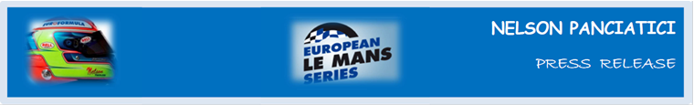

**LE MANS 24 HOURS 2013 (June 22 & 23)**

**AN IMPRESSIVE BATTLE FOR ALPINE A450 AND NELSON PANCIATICI!**

In eighth place at the start, Nelson Panciatici had positioned the Signatech-Alpine team’s Alpine A450 on a provisional podium in the LMP2 class. But the problems encountered by one of his co-drivers lost the number 36 more than 11 laps. Down in 51st place of the standings, the race became chase and they finally crossed the finishing line of these 24 Hours of Le Mans in 15th place, and ninth in LMP2 Class!

Nelson Panciatici was instrumental in this fierce battle up the field, adopting a punishing pace in all his stints:

Nelson: “*We never gave up, our Alpine A450 was nicely balanced and our Michelin tyres reliable which meant I could drive her to the limits with just the narrowest of security margins when I overtook. I didn’t make a brilliant qualifier as I was held up by traffic, a pole result may not have been on the cards but a place in the “top 4” was within our reach. The Alpine A450 was running well. I had a good start and was quickly in third place in LMP2 but the problems we ran into made us lose a lot of time, all we could do then was attack to show our potential and for our pleasure, that’s what I did! Everyone agrees, the Le Mans 24 Hours was a very difficult race this year, the track conditions kept changing and were treacherous, but with my co-drivers, Pierre Ragues and Tristan Gommendy, we did the best we could to battle up the standings. I think we performed well. I was obviously disappointed with the final result because we had legitimate hopes of reaching a podium. My last relay was the hardest but there was nothing to play for anymore. There is potential with this team and the Alpine A450… We proved it!”*

It was after the qualifiers that Philippe Sinault, Team Manager for Signatech-Alpine, told us: “*We’ve made a lot of progress with the behaviour of the car. It’s really satisfying. Nelson Panciatici put on a great performance even though there was traffic and the yellow flags didn’t allow him to finish in the front runners. We have stopped watching the stopwatch, from now on we will be watching the big clock!”* The race reassured him with regards to the performance of his team: “*Above all else we know the quality of our team. The work they’ve accomplished these last weeks and even more so during these 24 Hours, was exceptional. It makes me proud to see our mechanics rewarded by a jury. It’s important because it’s with them that we want to build the future. We were also able to gauge how much the public want to see the Alpine story continue. The race was difficult for our morale. We showed we had a great potential. The frustration was lessened by the amazing battle back up the field. We had to show what we’re capable of but only victory is sweet and we will do all we can to reach this new objective as quickly as possible!”*

The next meeting for the Signatech-Alpine team is on the Red Bull Ring in Austria for the third leg of the European Le Mans Series on July 19 and 20 and without a doubt their drivers will want to make Alpine’s colours shine again!

For more information on Nelson PANCIATICI, please visit[**www.nelsonpancia.fr**](http://www.nelsonpancia.fr)

[**facebook Join Nelson's Fan Club on Facebook!**](http://www.facebook.com/pages/Nelson-Panciatici/90065452450)