

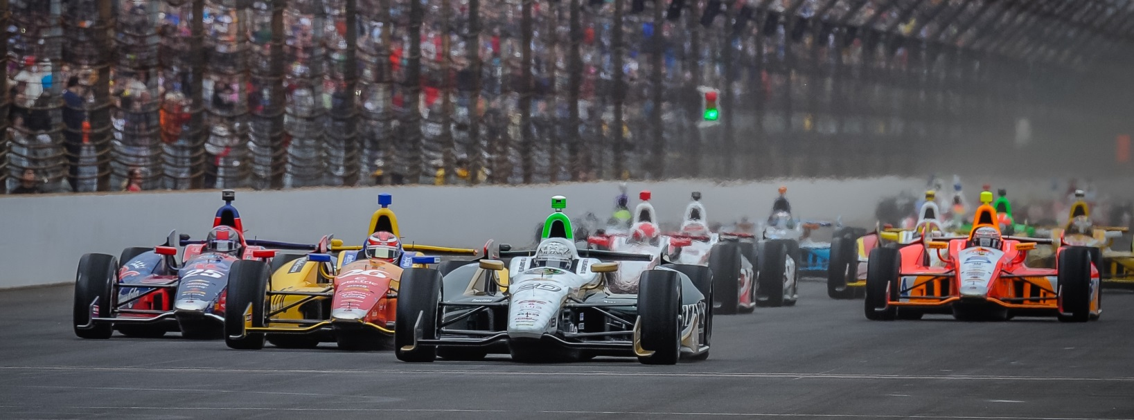

For Immediate Release Contact: Tom Blattler

317-525-5692

**MIKE CONWAY MAKES DEBUT IN #20 ECR/ FUZZY’S VODKA CHEVY FRIDAY IN ST. PETE VERIZON INDYCAR SERIES SEASON OPENER**

**IndyCar street race winner frustrated in Friday’s practice rounds**

**ST. PETERSBURG, Fla.  (March 28, 2014)** – Mike Conway and his ECR/Fuzzy’s Vodka team are in a learning curve as the British racing veteran works to blend in with the Indy-based single-car squad. And Friday’s opening rounds at the Firestone Grand Prix of St. Petersburg proved that case for Conway and his Fuzzy’s Vodka contingent.

The 10th annual Firestone Grand Prix of St. Petersburg is the season-opening contest for the 18-race Verizon IndyCar Series. The 110-lap Grand Prix will drop the green flag on the 2014 season at 3:27 p.m. EDT Sunday (March 30). ABC-TV will telecast the event live at 3 p.m.

Conway, a past street race winner at Long Beach and Detroit, took the No. 20 Fuzzy’s Ultra Premium Vodka Chevrolet to a best time of 63.633 seconds and an average speed of 101.833 miles per hour over the 1.8-mile temporary circuit near the St. Pete harbor. Takuma Sato was fastest Friday at 103.578 m.p.h.

In both the morning and afternoon practices, Conway quickly jumped to the top five with times in the 63-second range. Despite working with a variety of settings, Mike and the ECR crew were not unable to continue the momentum in the latter stages of sessions. Conway finished 20th in practice times that included the likes of Tony Kanaan, Charlie Kimball, Marco Andretti and Juan Pablo Montoya just in front of him on the charts.

“We didn’t find as much time as we wanted between sessions one and two,” said Conway, who’ll drive the No. 20 ECR/Fuzzy’s car in 12 road/street races in 2014. “We were struggling a bit to get the Fuzzy’s Chevy where we would like it in terms of time. We tried a lot of things today and we’ll study our data and see where we can improve for Saturday.

-2-

“The track wasn’t as bad with the grip level as usual. I think we can get better for the qualifying runs. I continue to learn with Ed’s team and we hope to find the proper settings that I like. It’s the season opener so you would like to come out of the gate well. I know we are working hard to find the best setup.”

Carpenter, a regular in the St. Pete starting lineup since 2007, took an unusual role Friday for this racing team as the defending Indy 500 pole winner stood on the ECR team’s timing stand and listened on the team’s radio. Carpenter has decided to race only at the six oval races in 2014 and also concentrating his team’s management.

“It was okay on the stand today,” said Carpenter, a two-time IndyCar race winner. “It’s a little hard on days like Friday because we didn’t do the best on the track. It was a disappointing day for Mike and the Fuzzy’s team. We thought we had some easy things to fix to make the car faster from the first outing this morning. But, in the second session today, the car just didn’t improve as we wanted. Now we have to work overnight and find the things to get the car better. We need give Mike what he needs. I know we’ll go through all of the data that we can to get the car better.”

Practice for the Verizon IndyCar Series continues Saturday at 10 a.m. EDT followed by Verizon P1 qualifying at 2:00 pm.

# # #

