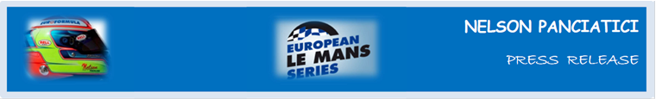
TEST DAY - LE MANS 24 HOURS 2014 (May 31 & June 1)
NELSON PANCIATICI IS BACK AT LE MANS DRIVING THE ALPINE A 450 B!
They finished third in the 4 Hours of Imola in the European Le Mans Series Championship and Nelson Panciatici and his Signatech-Alpine team hold third place in the provisional standings. This weekend they are at Le Mans 24 Hours’ Test Day for the whole team to focus on fine-tuning the Alpine A 450 b because, even though defending their ELMS title is their main objective, Le Mans 24 Hours is nevertheless the main event!

Although Nelson Panciatici is no stranger to Le Mans 24 Hours’ circuit anymore, he still has plenty to do. He will help the whole Signatech-Alpine team, managed by Philippe Sinault, optimize the tuning of the Alpine A 450 b.

With the Prix Jean Rondeau for best Rookie in 2012, Nelson Panciatici is confident as the day looms:

“We will have to get our marks as quickly as possible so that we can then focus on tuning the car with the new aerodynamic kit. The main objective of the day is to review all the tuning on the car and run endurance tests with all three types of tyres. We have the opportunity to work directly on Le Mans 24 Hours’ circuit which has characteristics not found anywhere else. The day will allow us to gather important data for the race even though there’s no rubber on the track, it will be a perfect warm-up. I feel comfortable in the team and I get on extremely well with my co-drivers Paul Loup Chatin and Oliver Webb, that’s important. We have a fast and reliable car, I have been on the Ellip6 simulator, watched videos and worked on the data my engineer, Olivier Bacchis, gave me. I’ve also been doing the appropriate physical training so I feel ready! This is our opportunity to get into race conditions with regards to pace as much as traffic. I really can’t wait to get there and rediscover the sensations I get in some parts such as the Porsche Curves. It’s a magical event, I’ve been waiting for this for nearly a year!

The Signatech-Alpine team finished mounting the Alpine A 450 b in the Alpine factory. This strong symbolic gesture underlines their desire to continue to perpetuate the sporting achievements of the make. Nelson Panciatici, supported by his co-drivers, intends to take in as much information as possible for the coming Le Mans 24 Hours which takes place on June 14 and 15. For the drivers a victory is important, but first they must focus on the tests!

For more information on Nelson PANCIATICI, please visit www.nelsonpancia.fr
Join Nelson's Fan Club on Facebook!

