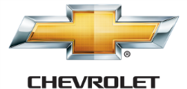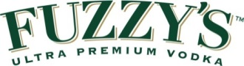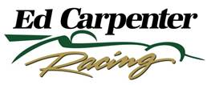

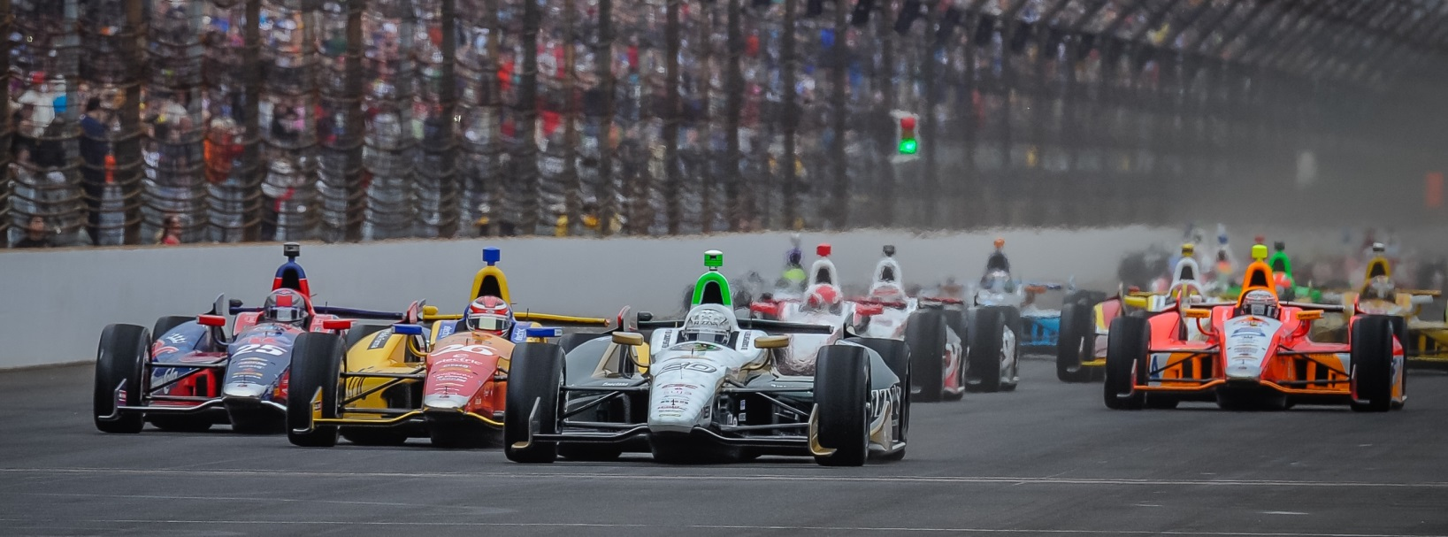

For Immediate Release Contact: Tom Blattler

317-525-5692

**CONWAY LOOKS FAST EARLY AT BELLE ISLE SUNDAY BUT SETTLES FOR 11TH IN RACE 2 OF THE CHEVY “DUAL IN DETROIT”**

**Fuzzy’s Vodka Chevy and Crew are quick but yellows don’t fall their way**

**DETROIT, Mich. (June 1, 2014)** – Mike Conway looked impressive early in Sunday’s Chevrolet Indy “Dual in Detroit” presented by Quicken Loans by leading four laps at the 2.36, 13-turn temporary circuit in the streets of Belle Isle.

In the end of the 70-lap feature, Conway had to settle for 11th in the No. 20 ECR/Fuzzy’s Ultra Premium Vodka Chevrolet.

Conway, the 2013 Dual race 1 winner, charged his way from his fourth starting position to take the lead on lap 21 over James Hinchcliffe and stretched his margin to 11 seconds before pitting for the first time on lap 25 in the Fuzzy’s Vodka Chevrolet.

Conway was the only driver to start the race on the harder “black” Firestone tires and the ECR decision looked to be a smart one with Mike’s superb speed by lap five. He slid by Ryan Briscoe, Carlos Munoz and pole winner Takuma Sato by lap 10. He then put pressure on Hinchcliffe from lap 14 to 20 before driving under the Canadian racer in turn three for the lead.

Conway pitted on lap 25 for the softer “red” tires and he moved back to second by lap 33. But the red tires started to lose their grip quickly and the 30-year-old Brit had to pit earlier than he wanted on lap 39. He pitted for fuel and tires on lap 49 to go to the finish. In that time, he lost his track position and had to fight his way through the field.

He passed six drivers in the last ten laps to place 11th at the checkered flag. Helio Castroneves led a Chevy 1-2-3-4 sweep Sunday.

Conway did set the second quickest lap of the race at one minute, 7.96 seconds, just .05 off Scott Dixon’s race best.

# # #

-2-

“Starting on the black tires was a good move today,” said Conway, who also won the Long Beach race this year. “I was able to get past several guys early. But, to be honest, Hinch (James Hinchcliffe) had power off the corners even with the red tires. And it took me some time to finally get under him in turn 3. I didn’t want to use up all of my ‘overtakes’ too early in the race. That amount of time trying to get by him cost us at the end of the race.

“The red tires were pretty good for me. They went off a little but I was pushing hard. The right front tire was locking up and it was getting worse. So I decided to pit early for the fresh black tires or I was going to crash. It is tough to pass here and I made some good ones today. At the end, I was pushing every lap like a qualifying lap. And it was fun and we learned some more for the team. I was happy how the car was hooked up. We just didn’t get the yellows to fall our way today. It was fun to push the car as hard as I did. I just wish for a better result today. Now, it’s on to Houston for me next.”

Ed Carpenter, team owner and oval driver for ECR, called the race strategy today and felt the circumstances just didn’t fall Conway and his team’s way.

“Mike was fast today and we thought the black tires early would be an advantage,” said Carpenter, the 2014 Indy 500 pole winner. “He made the right moves too. I think Hinch held him up a bit and that hurt. But the yellows and the timing just didn’t fall our way. But I’m pleased with Mike’s performance and the team effort to come back strong from Saturday’s mishap. I think we are making some good progress with the road and street program at ECR.”

Carpenter will be back in the cockpit of the Fuzzy’s Vodka Chevy next Saturday night (June 7) at the fast 1.5-mile oval at Texas Motor Speedway for the Firestone 600k set for 7:30 p.m. CDT. The race will be televised on the NBC Sports Network at 7 p.m. CDT.

# # #

