

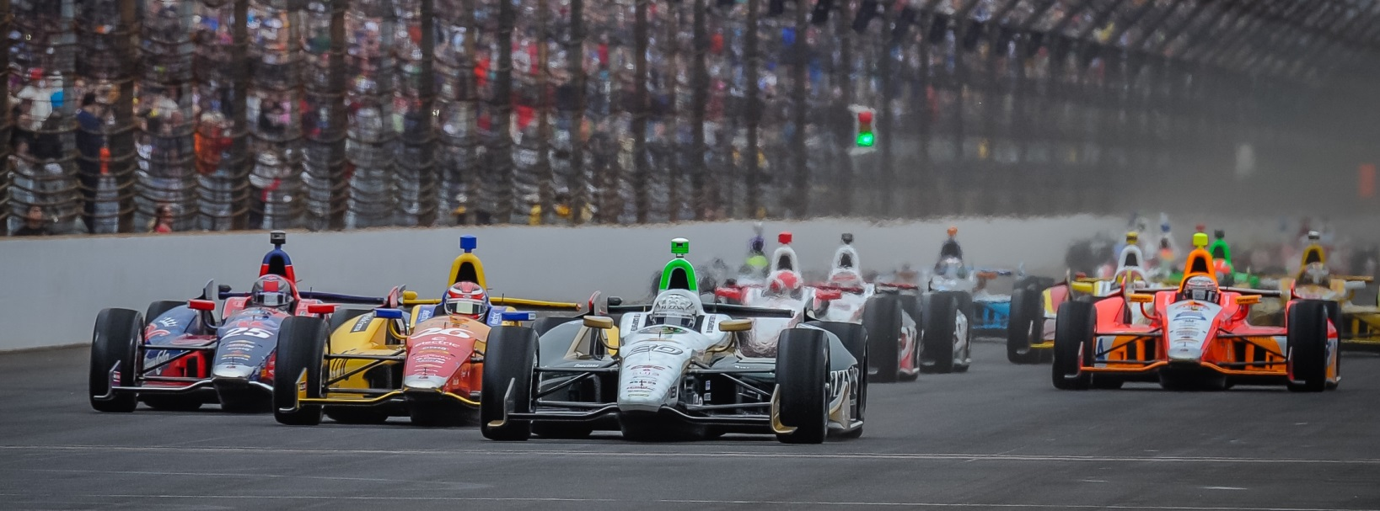

For Immediate Release Contact: Tom Blattler

317-525-5692

**MIKE CONWAY TAKES FUZZY’S VODKA CHEVY TO 12TH SATURDAY IN FIRESTONE GRAND PRIX OF ST. PETERSBURG QUALIFYING**

**Delayed Time Trials Prove Help Conway in Wet Conditions**

**ST. PETERSBURG, Fla.  (March 29, 2014)** – Mike Conway ran up front for much of the second round of Verizon IndyCar Series qualifying Saturday in the streets of St. Petersburg before the driver of the No. 20 ECR/Fuzzy’s Ultra Premium Vodka Chevrolet settled for 12th in the season opener of the 18-race series.

Conway, in his first race for Ed Carpenter Racing, advanced from the first round of time trials in the rain-delayed qualifying session Saturday afternoon. The green flag didn’t drop until 5:35 p.m. EDT on a rain-drenched 1.8-mile temporary circuit near St. Petersburg harbor. Conway took the No. 20 Chevy to third in the first round and looked fast in the second group of 12 drivers seeking positions for Sunday’s 110-lap Firestone Grand Prix of St. Petersburg.

The ECR/Fuzzy’s crew rolled the dice at the start of the second session by giving Conway Firestone red slicker tires despite various rain puddles around the course. Conway immediately jumped to the top of the speed charts for his second, third, fourth and fifth laps. Unfortunately, the track conditions improved later in the round when Conway didn’t have optimum tires.

The England native placed 12th in the second round with a best time of 63.961 seconds and an average speed of 101.310 mile per hour. Takuma Sato won the pole position at 104.738.

“We generated a lot of tire temperature early in the second session of qualifying when the track was a bit damp,” said Conway.  “We are still missing something in the car though. We need to look at it overnight. The 12th spot might have been a little better than what we thought coming into qualifying.”

-more-

-2-

The start of the St. Petersburg race has been wild in the past with the long front straightaway utilizing the Albert Whitted Airport. Many times the drivers and their machines have gone five six wide entering the first turn at the start of the Grand Prix. Sunday’s start could be the same.

“The start of the race here is always pretty wild,” said Conway. “You can’t take it too easy and you can’t be too aggressive either. You need to be aware of what and who is around you. We will need to make up some positions early and I hope we can do that in the first lap. Even though it bottlenecks into turn one, you usually can go two or three wide through there. You need to find the space to get through the turn.”

Carpenter, watching from the timing stand for the first time as a team owner, was pleased with Conway’s performance despite the tough track conditions.

“We felt like the track was ready for slicks at the start of the second session,” said Carpenter. “And we were right in that regard. Mike was P1 in his first four or five laps. If we could have caught yellow in there, we would have been in good shape. It ended up hurting us in the end because Briscoe and Mike started on slick reds and we probably used the best part of the tires before the track got better. So the guys who waited a little bit longer to go to slicks had an advantage at the end. But we also have some work to do to get the car better too. We need get Mike more confident with the car. We’ll keep chipping at it. The rain probably helped us the first group with the wet track. I think the transfer was more on Mike than the car then. I was happy with job he did in qualifying. We’ll look for a solid run on Sunday.”

Sunday’s Firestone Grand Prix of St. Petersburg will begin Sunday at 3:27 p.m. EDT.

# # #

**Verizon IndyCar Series drivers do a “selfie” during the rain delay today at St. Petersburg.**

