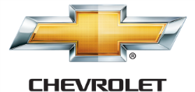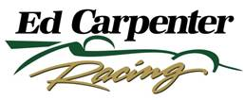

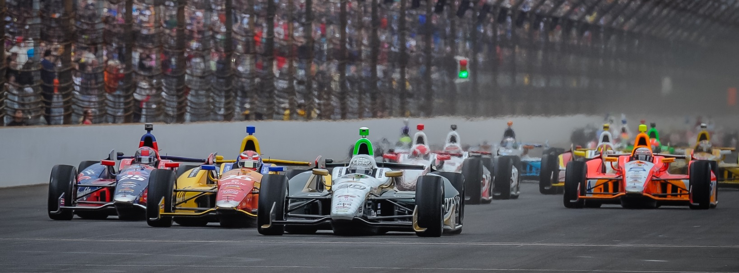

For Immediate Release Contact: Tom Blattler

317-525-5692

**MIKE CONWAY’S ECR DEBUT IS IMPRESSIVE, CHARGES TO 3RD BEFORE COMMUNICATION TROUBLE HALTS A POSSIBLE PODIUM**

**New ECR/Fuzzy’s Vodka racer storms towards the front, takes 16th**

**ST. PETERSBURG, Fla.  (March 30, 2014)** – Mike Conway’s debut in the No. 20 Fuzzy’s Ultra Premium Vodka Chevrolet open many eyes Sunday in the 110-lap Firestone Grand Prix of St. Petersburg. But the 16th place didn’t tell the whole story for the personable British racer.

Conway, 30, charged to third from his 12th starting position in the middle of the Verizon IndyCar Series season opener before a communication issue cost him a possible podium finish. The Detroit race winner passed the likes of Ryan Hunter-Reay, Scott Dixon and Justin Wilson in his newest mount and was hoping to make a charge at leaders Will Power and Helio Castroneves.

However, a radio communication miscue derailed Conway’s chances when the full course yellow flag appeared on lap 76. Mike couldn’t hear the call from the ECR pit area to pit on lap 77 and he stayed on the track. He pitted on the last lap but accidently passed the pace car to enter the pit area. That confusion caused a “drive through” penalty in the contest and Conway was out of contention and in 16th place.

“As the day went on, we steadily moved up and we got to third,” said Conway. “I think we had a different strategy from other people. We made some big gains on the red Firestone tires and drove by many people today. So that was very positive. I wasn’t hoping for a safety car there. I wanted to hold the gap when we went to the black tires. Then I didn’t hear a radio communication to come into the pits. I thought the safety car waved me by but they were waving (James) Hinchcliffe by instead. I don’t know if there was a communication problem there too. I didn’t know if they waved at me or both of us. Then they said it was only for Hinch.  And that was it.  It screwed up our whole day. That is definitely frustrating after driving to third.”

-more-

-2-

Team owner Ed Carpenter, in his first race outside the cockpit for his own team, was positive after the race and enjoyed his experience on the radio Sunday.

“Obviously, at the end of the day, we are all a little disappointed with the result,” said Carpenter, the 2013 Indy 500 pole winner. “I think the positives outweigh the negatives today. In my mind, we made some major gains with Mike (Conway) and the car throughout the weekend. The pace in the race was very good as we had the third quickest lap. The building blocks are there for down the road. We made some mistakes on the pit stop and passing the pace car. There are some things we learned today. We need to do a better job communication wise. I’m pleased how the team came together this weekend. There is some real potential here.”

Carpenter’s new experience in the pits gave him a different perspective during the races and helps him understand how his team operates in racing environment.

“It was a new experience for me being on the time stand for the first time as a team owner,” Carpenter explained. “The only other time I have stood on the stand that long is when I had an early DNF in a race. It was a learning experience for me today as I watched what the guys do on the stand and during the races. I was able to see how strategies unfold. It was very enjoyable when Mike was marching to the front. Whether you are in the car or out of the car when things are not going well, it isn’t as much fun. We look forward to Long Beach now.”

Conway, the 2011 Long Beach race winner, is also looking forward to his return to famed Toyota Grand Prix of Long Beach set for April 11-13.

“Long Beach is one of the world’s greatest street races and I’m excited to get back there,” said Conway. “It was a real thrill winning that race and see my name listed with all of the famous drivers who have won there. I’d love to win Long Beach again.”

