

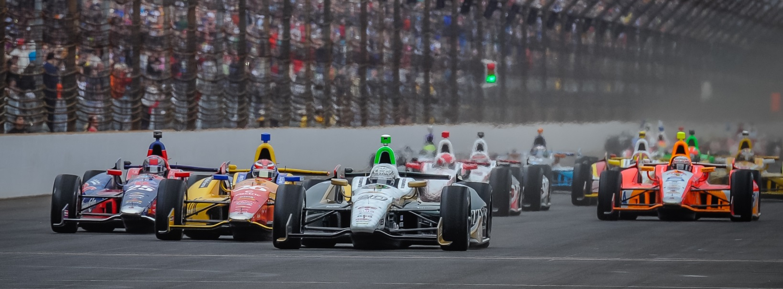

For Immediate Release Contact: Tom Blattler

317-525-5692

**MIKE CONWAY RETURNS TO LONG BEACH FRIDAY IN 14TH**

**DURING VERIZON INDYCAR SERIES GRAND PRIX PRACTICE RUNS**

**2011 Long Beach Winner Works With His New Team For More Speed**

**LONG BEACH, Calif.  (April 11, 2014)** – Mike Conway came back to the site of his first Verizon IndyCar Series win Friday with his new Ed Carpenter Racing/Fuzzy’s Vodka squad in hopes of establishing a foundation towards another Toyota Grand Prix of Long Beach triumph.

The 30-year-old England native, who won the 2011 Long Beach classic in dramatic style, posted consistent top 10 speeds in the two practice sessions over the 1.968-mile, 14-turn temporary circuit near the famed Queen Mary.

At the end of the day, Conway had to settle for 14th overall with a best time of 69.851 seconds and an average speed of 101.427 miles per hour. With five minutes to go in the Friday afternoon session, Mike was eighth as the team continued to find additional speed with the No. 20 Chevrolet-powered machine.

At the midway portion of practice, Conway ranked fifth on the timing charts and was just four-tenths off the No. 1 spot. In the morning practice, Mike placed eighth with a time of 70.207 seconds. Overall, Simon Pagenaud was the quickest in the 23-driver field with a speed of 102.457 m.p.h.

“I just love coming back to Long Beach,” said Conway, who also won last year in the streets of Detroit. “It has special meaning for me since I won here in 2011. It’s a sensational event. I’m very proud to have my photo and name in Victory Lane here. The great history of the Long Beach Grand Prix is just legendary. The whole atmosphere around the race is something you don’t see at other races.

-more-

-2-

“Today we tried several settings with car to gain better grip. It was getting better with each run. We attempted some things late in the afternoon session and I didn’t gain the speed I was hoping for. We’ll sit down and go over the data this evening and be ready for Saturday. The standing start here at Long Beach will be interesting too. I think it will be exciting for the fans at Long Beach. It will have them on their feet.”

Team owner Ed Carpenter, who started the last two Long Beach races as an owner/driver, says the team is making strides with Mike and Fuzzy’s Vodka Chevy despite the 14th posting Friday.

“We were eighth in the morning session on one set of tires,” said Carpenter, 2013 Indy 500 Pole Winner. “We ran 17 laps and Mike was very strong. Some other cars put on a second set of tires too. In the afternoon, we made up some more time as the track gained more rubber. I think we are moving in the right direction for qualifying and the race now. Don’t forget, we are still learning with Mike and he is learning with our team too. I feel good about the weekend for Mike and the ECR/Fuzzy’s team now.”

Qualifying for the 40th annual Toyota Grand Prix of Long Beach begins at 1:15 p.m. PDT Saturday. The green flag will drop Sunday for the 80-lap feature with the impressive standing start at 1:43 p.m. PDT. The race will be televised live on NBC Sports Network.

# # #

