

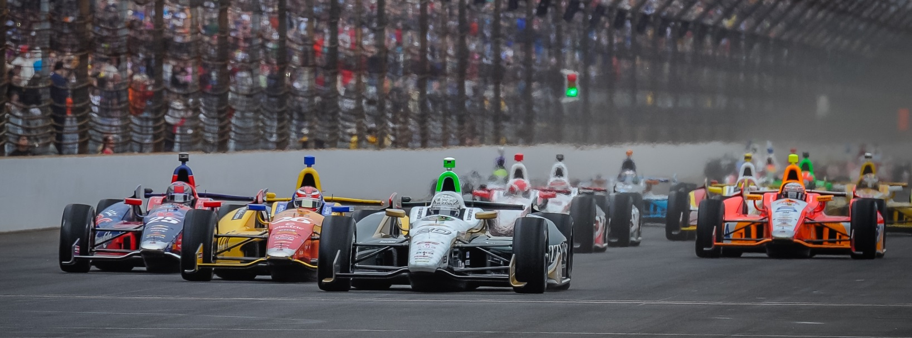

For Immediate Release Contact: Tom Blattler

317-525-5692

**CONWAY PLACES 17TH IN LONG BEACH QUALIFYING SATURDAY;**

**STRANGE SESSION SEES MANY CONTENDERS NOT IN TOP SIX**

**ECR/Fuzzy’s Vodka Driver Hopes for a Strong Run in Sunday’s Race**

**LONG BEACH, Calif.  (April 12, 2014)** – Mike Conway wasn’t able to transfer out of the opening round in Saturday’s qualifying for the 40th Toyota Grand Prix of Long Beach in the No. 20 ECR/Fuzzy’s Ultra Premium Vodka Chevrolet.

Conway, the 2011 Long Beach winner, looked impressive in the Saturday morning practice with the quickest lap late in the 45-minute session. And the Ed Carpenter Racing squad was set for a strong performance for the coveted Verizon P1 Pole Position.

However, Conway’s machine didn’t duplicate the morning runs with a best of 1 minute, 8.592 seconds at an average speed of 103.322 miles per hour. Unfortunately, the 30-year-old Brit had to settle for ninth in the first grouping in round one, failing to make a top six transfer spot. Others like Will Power, Takumo Sato, Tony Kanaan and Juan Pablo Montoya did not transfer too.

Conway will start 17th in Sunday’s 80-lap feature around the 1.96-mile, 12-turn legendary temporary circuit. Ryan Hunter-Reay (104.462 m.p.h.) won the pole followed by James Hinchcliffe and Sebastien Bourdais. The top 21 drivers were separated by less than a second.

“That is not what we were expecting today for qualifying,” said Conway, the 2013 Detroit race winner. “We just couldn’t get the tires right where we wanted them. Things just didn’t fall our way today. We do have an extra set of tires for the race now that could help us. We’ll have to make some adjustments overnight and be ready for the race.”

Sunday’s 40th edition of the famed Long Beach street event marks the first time for a standing start with the IndyCar Series at the “Roar by the Shore.”

-more-

-2-

“The standing start will be interesting here,” said Conway, a veteran of standing starts. “I think there is enough room for everyone at the start. We were okay last year at Toronto but there were some issues at the Houston race with some guys stalling. I need to be consistent with clutch to get a good start on Sunday. The start should be fun for the fans too.”

The 23-driver field will take the Long Beach Grand Prix green flag at 1:43 p.m. PDT and the race will be televised live on NBC Sports Network.

# # #

