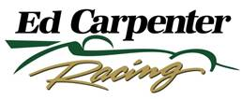

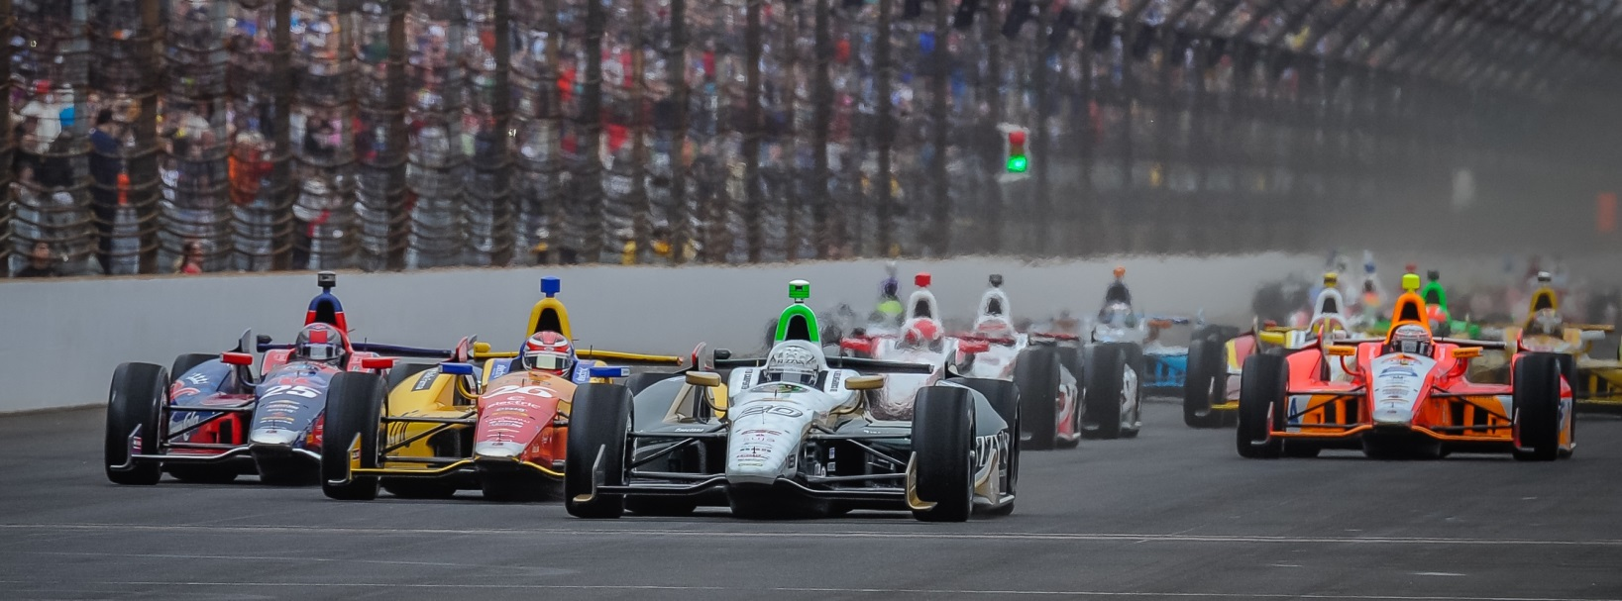

For Immediate Release Contact: Tom Blattler

317-525-5692

**CONWAY HOLDS A BUSY SCHEDULE SINCE HIS LONG BEACH WIN;**

**TAKES ECR/FUZZY’S VODKA CHEVY TO 16TH FRIDAY AT BARBER**

**Long Beach Champ looks for traction on tricky 2.38-mile circuit**

**BIRMINGHAM, Ala. (April 25, 2014)** – It felt good to be back in a race car for Long Beach winner Mike Conway Friday at Barber Motorsports Park, the third round of the 18-race Verizon IndyCar Series. Conway returned to the cockpit of his race-winning No. 20 Fuzzy’s Ultra Premium Vodka Chevrolet in Friday practice.

Conway, the “come-from-behind” victor in the streets of Long Beach two weeks ago, has been busy off the track since his California triumph on April 13 in the “Roar by the Shore.” The 30-year-old Brit flew back to the UK for the WEC sports car event at Silverstone and then to his home in Scottsdale, Ariz., to move into a new condo before landing Wednesday evening in Birmingham.

“It’s been a busy time for me since the win at Long Beach,” said Conway. “I flew back to the UK for the WEC race at Silverstone, Unfortunately, the sponsorship for the LMP2 effort didn’t come through for the race so I didn’t drive. But I did get to see the Toyota Hybrid P1 team place 1-2 there. I helped with the testing on that car so it felt good to be there and watch the win. I then flew back to Scottsdale and moved from my house to a condo on Monday and Tuesday. On Wednesday, I flew to Birmingham for a media day on Thursday, so it felt good to get back in the race car today (Friday).”

Conway, the 2013 Chevrolet “Duals in Detroit” race 1 winner, posted the 11th best time in the first Friday practice with a time of one minute, 9.497 seconds at an average speed of 119.140 miles per hour. Mike found the racing surface not as quick in the afternoon session with the temperatures rising at the 17-turn permanent circuit. Conway clocked a 1:09.504 in the second practice. Overall, Conway was 16th best Friday. Ryan Hunter Ray was fastest at 120.378.

-more-

-2-

“We didn’t have the grip level in the practice sessions that we wanted,” explained Conway. “This place is challenging and tough to get everything just right. But we’ll work overnight and be ready for Saturday’s practice and qualifying.”

Conway is scheduled to qualify Saturday afternoon at 2 p.m. CDT in the opening group of the first round of Firestone Fast Six time trials. If Mike can record a top-six in the first round, he’ll transfer to the second round. The final qualifying round pits the top six overall in a dash for the pole position.

“Qualifying at Barber is a tough one,” said Conway. “You are always on the edge to get a strong lap. I’m not sure you can drive a perfect lap at Barber. But you have to push it to the limit for a shot at the fast six. It isn’t easy.”

The green flag will fall at 2:12 p.m. MDT Sunday for the 90-lap main event. The race will be televised live on NBC Sports Network.

# # #

