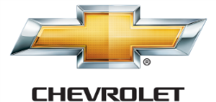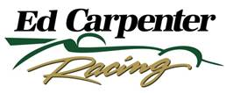

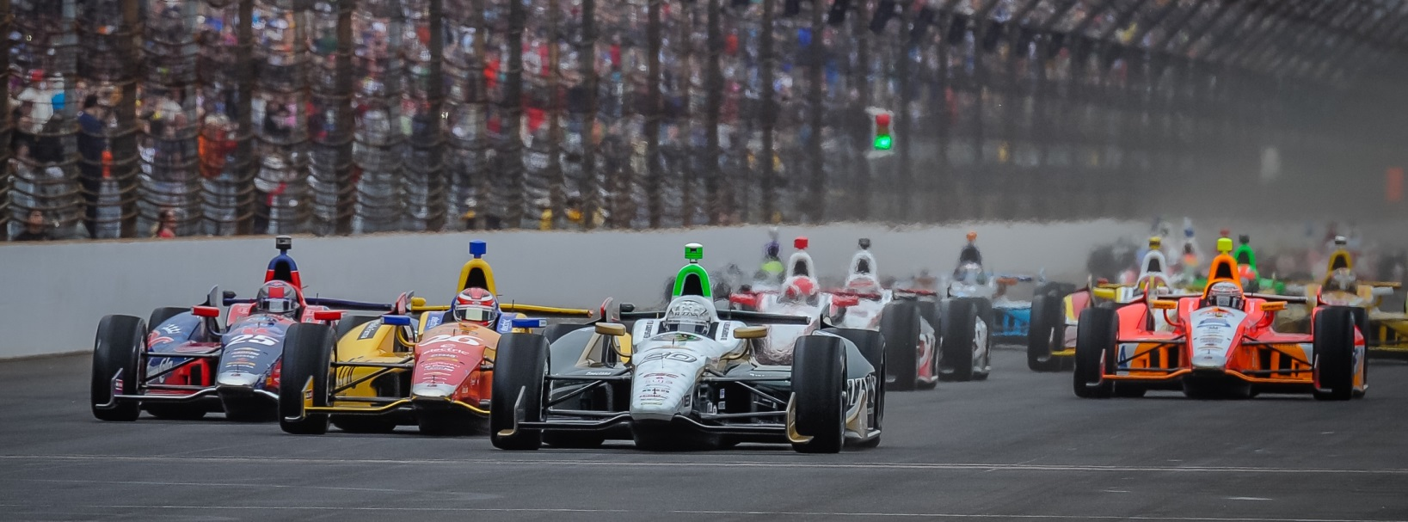

For Immediate Release Contact: Tom Blattler

317-525-5692

**FRUSTRATED DAY OF WET AND DRY CONDITIONS FOR CONWAY SUNDAY AT BARBER MOTORSPORTS PARK, SETTLES FOR 14TH**

**Long Beach Winner Moves from 21st to 14th in 3rd Verizon Series Race**

**BIRMINGHAM, Ala. (April 27, 2014)** – It was a tough day for Long Beach winner Mike Conway Sunday in the delayed 69-lap Indy Grand Prix of Alabama in the No. 20 Fuzzy’s Ultra Premium Vodka Chevrolet at the beautiful Barber Motorsports Park.

Conway, starting 21st, had a big chore ahead of him from the pack of the field and the tremendous thunderstorms on the 2.38-mile, 17-turn permanent circuit made conditions even more treacherous at the difficult track. The race was delayed for nearly two and a half hours as a wild storm blew through the Birmingham area. Spectators were asked to return to their cars as the rain, wind, lightning and thunder pounded the facility.

Finally, at 4:35 p.m. CDT, the green flag was thrown with all 23 cars equipped with the Firestone rain tires. The wet racing surface continued to dry as the all of the drivers took on slicks by lap 25.

Conway’s machine didn’t have the overall grip he was looking for with the rain tires and his mount improved a bit with the sticker Firestone red rubber. By lap 39, the British native moved into the 14th position with hopes of a shot at the top-ten. The ECR team then called Conway to the pits on lap 47 for the final pit stop. Mike fought with Takuma Sato and Jack Hawksworth in his pursuit of a top-ten finish but had to settle for 14th when a late race caution period slowed the field to the checkered flag.

“It was a pretty long day for us today,” said Conway. “I guess we’ll have to take 14th after starting 21st. We struggled in the wet with overall grip. I tried to make a few moves in the early portion of the race and they just didn’t work out. We felt quicker on the slicks, especially on the earlier segments of the runs. But once everyone had their tires up to temperature, we couldn’t get up to make a move. It’s frustrating. I hope we can improve on the road circuits.”

Conway, now fifth in the current Verizon IndyCar Series point standings, will move onto the upcoming test this Wednesday at the road course at the Indianapolis Motor Speedway in preparation for the inaugural Grand Prix of Indianapolis. The first IndyCar Series road racing event at IMS is set for May 8-10.

“I’m excited to go to Indy for the test this week on the new road circuit,” said Conway. “The race in the upcoming Grand Prix of Indianapolis will be huge for all of the drivers. I think everyone would love to win the first IndyCar road race at Indy. But we need to work on the setup some more to fight for a win that weekend.”

Practice begins on Thursday, May 8, with the inaugural race scheduled to start at 3:30 p.m. EDT on Saturday, May 10.

Practice for the 98th running of the Indianapolis 500-Mile Race will open on Sunday, May 11. ECR team owner/driver Ed Carpenter and his teammate J.R. Hildebrand will drive the No. 20 Fuzzy’s Ultra Premium Vodka Chevrolet and the No. 21 Preferred Freezer Services Chevrolet respectively on the famed 2.5-mile oval.

# # #

