

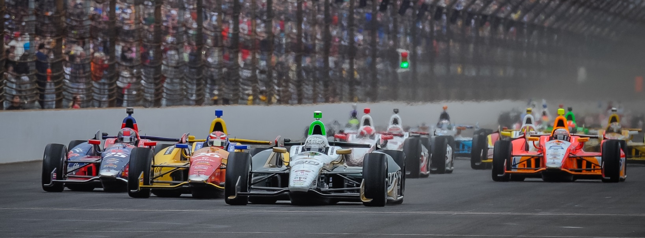

For Immediate Release Contact: Tom Blattler

317-525-5692

**TOUGH DAY FOR CONWAY AND ECR/FUZZY’S TEAM THURSDAY**

**IN OPENING DAY OF ACTION AT GRAND PRIX OF INDIANAPOLIS**

**Long Beach Winner cannot get a good grip level with the No. 20 car**

**INDIANAPOLIS (May 8, 2014)** – It wasn’t the best of days for Mike Conway and his Ed Carpenter Racing/Fuzzy’s Vodka racing team in the opening round of the inaugural Grand Prix of Indianapolis Thursday on the sensational 2.4-mile road course inside the Indianapolis Motor Speedway oval.

Conway, the reigning Toyota Grand Prix of Long Beach champion, had difficulty gaining a proper grip level with his popular No. 20 Fuzzy’s Ultra Premium Vodka Chevrolet during the two practice sessions Thursday under sunny skies.

In the morning round, Conway recorded a best time of one minute, 12.01 seconds for an average speed of 121.796 miles per hour. After some changes with chassis setup, Conway improves in the afternoon 45-minute practice round with a clocking of 1:11.568 and a speed of 122.685 m.p.h.

Fastest in the first day was defending Verizon IndyCar Series champion Scott Dixon with a 124.606 m.p.h. lap in his Chevrolet-powered car.

“It was a tough day for us,” said Conway. “We are struggling to get the grip level right now. We thought we had some things figured out at the test, but it didn’t work out today. It is very exciting to run the road circuit at IMS for the first time. It’s a beautiful circuit. I think it will be a very entertaining venue for the race fans on Saturday. We’ll work hard overnight to improve the car and get it better for qualifications. There is rain in the forecast for Friday and that could change a lot of things for everyone here.”

Qualifying is set for Friday at 2 p.m. EDT with Firestone Fast Six runs. The green flag will fall at 3:50 p.m. EDT Saturday for the 82-lap Grand Prix, which will be televised live on ABC-TV.