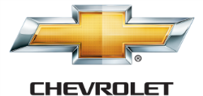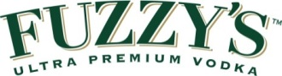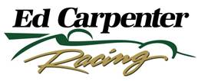

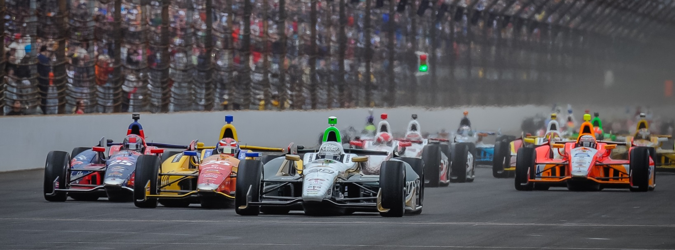

For Immediate Release Contact: Tom Blattler

317-525-5692

**FIRST LAP INCINDENT TAKES CONWAY OUT OF CONTENTION**

**IN SUNDAY’S SHELL/PENNZOIL GRAND PRIX OF HOUSTON**

**British Driver Fights His Way from Last to 13th Place Finish**

**HOUSTON (June 29, 2014)** – For the second day in a row, an early incident in the Shell/Pennzoil Grand Prix of Houston hurt Mike Conway’s chances of scoring a solid finish Sunday in the tough heat and humidity at the MD Anderson Cancer Center Speedway near the Astrodome. Conway placed 13th in the second Houston race Sunday.

Conway, who started 17th in the No. 20 Fuzzy’s Ultra Premium Vodka Chevrolet, made contact with Marco Andretti in the chicane in the opening circuit of the 90-lap race and the impact forced the left front wing into the left front tire. Mike needed to make a pit stop immediately and the ECR/Fuzzy’s crew replaced the entire front wing assembly, added fresh Firestone tires and fuel.

Conway returned to action just in front of the lead pack and fought off the challenges of leader Helio Castroneves for nearly 30 laps in his attempt to stay on the lead lap. On the harder black tires, Conway actually clocked quicker laps than the leaders later in the stint.

On lap 29, Conway pitted again for fuel and tires. Unfortunately, he could not hold off Castroneves and was a lap behind the Penske driver by the 31st circuit.

Conway continued to run with the leaders before INDYCAR officials asked Mike to move over for the front runners to battle on the 1.7-mile, 10-turn temporary course carved through the parking lot of the nrg Stadium, home of the Houston Texans NFL team.

Despite driving with a sprained left thumb from Saturday’s tire barrier incident, Conway worked his way from last on the first lap to 13th at the checkered flag.

Simon Pagenaud took his second victory of the 2014 Verizon IndyCar Series followed by rookies Mikhail Aleshin and Jack Hawksworth. Rounding out the top-five Sunday were Charlie Kimball and Sebastien Bourdais.

-2-

“Going into the chicane on the first lap, Marco (Andretti) made a move in front of me and I couldn’t stop quick enough,” said Conway. “It clipped the front wing and I think it cut the tire too. So I had to pit immediately and that really killed the race for us. I thought I could get away with it but it cut the tire. My (left) thumb was okay during the race after spraining it Saturday. It felt a little numb at times because I think the tape might have be a little too tight. But it was okay. I just tried to fight back and stay on the lead lap as long as I could.

“It was hot in the car but I felt pretty good. I was able to get some air coming into my visor during the yellows. I had a close call with a piece of carbon that flew up from (Luca) Filippi’s car. It hit the right mirror and almost me. It was close to hitting me in the head. That would have hurt.”

The Verizon IndyCar Series now moves to Pocono Raceway next weekend for Sunday’s 500-mile competition at the “Tricky Triangle” with Texas winner Ed Carpenter jumping back into the Fuzzy’s Vodka Chevy. Carpenter won the Fontana 500-mile event in 2012 and figures to be one of the contenders for another 500 victory.

The Pocono 500 presented by Sunoco will have qualifying on Saturday, July 5, and the 200-lap feature begins at 1 p.m. EDT on Sunday, July 6.

# # #

