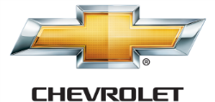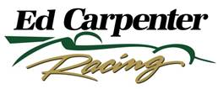

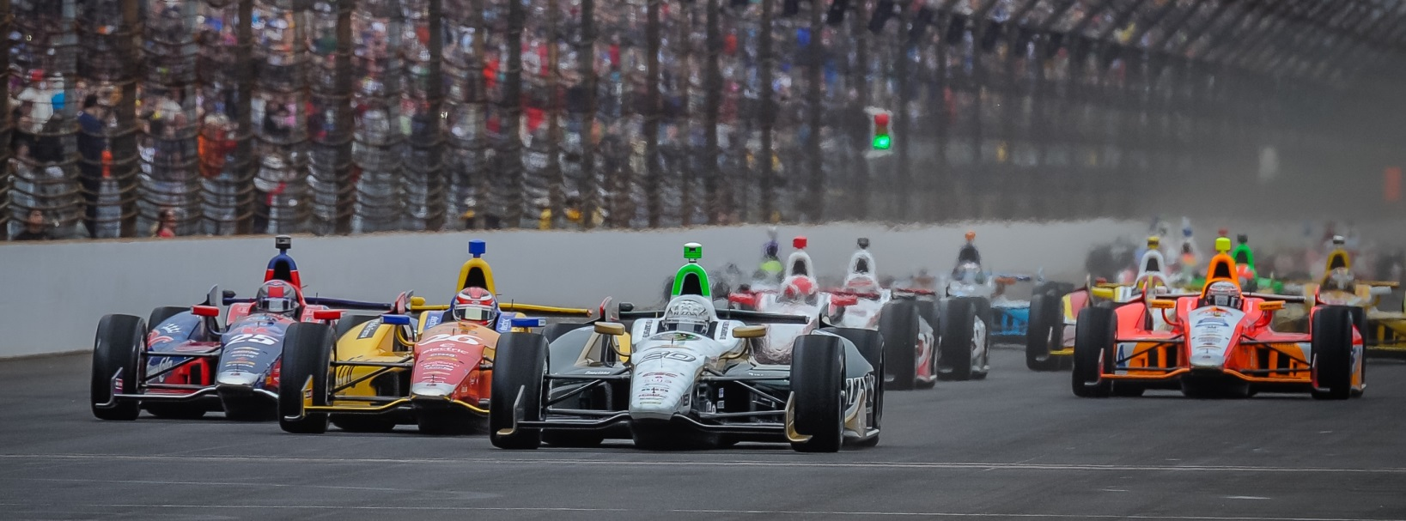

For Immediate Release Contact: Tom Blattler

317-525-5692

**CONWAY, ED CARPENTER RACING SEEKS ANOTHER 2014 WIN**

**AS ONE-CAR TEAM PLAYS SPOILER FOR TITLE CONTENDERS**

**3-Time Winning Squad Could Upset the Big Teams Again**

**LEXINGTON, Ohio (July 29, 2014)** – Coming off another upset win at Toronto two weeks ago, Mike Conway and his Ed Carpenter Racing team will play the spoiler again this Sunday at the Mid-Ohio Sports Car Course.

With just four races remaining in the 18-event Verizon IndyCar Series trail, Conway, his team owner Ed Carpenter and the Fuzzy’s Ultra Premium Vodka Chevrolet contingent have become the first team not named Ganassi, Penske and Andretti to win three races in a season since 2004. Rahal Letterman Racing and Fernandez Racing won three each in 2004.

Conway’s wins in the streets at Long Beach and Toronto and Carpenter’s victory at Texas have proven that the “little guy” can still be a factor against the “Super Teams.” Taking on the three-car Penske operation and the four-car Ganassi and Andretti armadas, the single-car unit of ECR comes to Mid-Ohio this weekend for the 90-lap feature with upset on its mind again.

The tough 2.25-mile, 13-turn permanent road circuit in the rolling hills of Ohio is always a physical test for the drivers and Conway, the 30-year-old Brit, feels he is ready for the challenge.

“We were able to test the car last week and that has helped us coming back to Mid-Ohio for the race,” said Conway. “It’s crazy to think I have only two races left in the year with ECR and the same for Ed (at the ovals). But the win at Toronto has our team pretty bumped up and we are excited for the Mid-Ohio event. It’s a very tough race on the drivers, especially if it is hot.”

The heat hasn’t been a factor for Conway as he trains near his Scottsdale, Ariz., home and survives the brutal workouts each day in the 100-plus heat.

-more-

-2-

“A hot, humid day at Mid-Ohio can really take a lot out of a driver,” Conway admits. “Towards the end of a race you can see some drivers making mistakes and you need to be ready to take advantage at that point. I feel my fitness is right there with anyone in the series. But we all know how hard Mid-Ohio can be for us.”

Conway’s shared ride with Carpenter has been one of the most unique stories of the 2014 Verizon IndyCar Series campaign, as Mike drives the No. 20 Fuzzy’s Vodka Chevy in 12 events with Ed handling the reigns in the six oval races.

“I think this year has been a perfect match for us in the current situation,” said Conway. “I was through with the oval races two years ago after another bad crash at Indy. So I just wanted to drive the roads and streets. And Ed wanted to concentrate on the ovals and helping his team more behind the scenes. So it has been successful and I’m working better with team each week too.”

For Carpenter, it was a very difficult decision to step out of the race car at the road and street contests. But the Butler University marketing graduate had a purpose to his madness.

“As a team owner, I wanted to be competitive at every race if possible,” Ed explained. “I had improved in my road racing but I wasn’t going to win a race there. If I concentrated on the ovals, and we had Mike on the roads, we could have the Fuzzy’s Chevy in the battle each race. It was a learning process with a new driver on the team but we have won three races too.”

The combo of Conway and Carpenter have the ECR organization in seventh place in the entrant points for the Verizon IndyCar Series, just one point from last year’s series champions Scott Dixon and the Target Chip Ganassi team.

“We felt we could challenge the big teams for the entrant title if everything came together,” said Carpenter, who will drive at Milwaukee and Fontana in August. “We are a bit behind right now but we sure could throw a wrench in the title contenders’ run for a championship. That is our plan right now. And hopefully with another win for Mike this weekend at Mid-Ohio.”

Playing the spoiler has been Conway and Carpenter motto all season long and they could continue to play that role this weekend when the cars rolled at 3:45 p.m. EDT Sunday.

# # #

