

**EUROPEAN LE MANS SERIES 2014 – ROUND 3**

**4 HOURS OF RED BULL RING (July 19 & 20 2014)**

**VICTORY FOR ALPINE AND NELSON PANCIATICI!**

The Signatech-Alpine squad and Nelson Panciatici won the 4 Hours of Red Bull Ring at the end of a truly breath-taking race! The victory has vaulted Alpine into the lead of the European Le Mans Series title standings just two rounds from the end of the campaign.

Having lapped fifth-fastest during free practice on Saturday, Signatech-Alpine proceeded to qualify on the third row of the grid, a mere 224 thousandths-of-a-second adrift of the front row. After taking the start from fifth position, Nelson Panciatici went immediately on the attack and had already advanced to third by the end of the opening lap. Relentlessly aggressive through the traffic, Nelson was still in third place when he handed over the wheel to his team-mate, after which the Alpine A450b continued its progression up the order to take the chequered flag just over 12 seconds to the good! This first triumph of the season resulted in the Marseillaise ringing out around the Austrian Alps and catapulted Signatech-Alpine into the lead of the Teams’ standings!

Philippe Sinault (Signatech-Alpine Team Principal): *“Everybody in the team has worked extraordinarily hard all weekend to achieve this fantastic result – so I must congratulate the team in its very broadest sense. Nelson made an exceptional start to the race and was able to stay in touch with the leader. Paul-Loup then maintained the same excellent rhythm throughout his three stints despite the intense heat, whilst Oliver regained the lead and drove the car home to victory at the end. This is a great victory for the entire team, achieved with panache – but we cannot afford to rest upon our laurels. There are still many contenders in the mix for the title. Our objective was to remain in the hunt!”*

Nelson was also satisfied: *“I knew that I needed to make a really good start and keep in touch with the leader, and I fought hard to stay as close as possible… Paul-Loup and Oliver both drove brilliantly during their stints, and the whole team deserves to be congratulated. Even more than the performance, it was the manner in which we achieved this victory that is particularly satisfying!”*

The team’s defence of its 2013 crown will continue at Le Castellet in southern France on September 13-14, where last year Signatech-Alpine clinched the championship crown!

For more information on Nelson PANCIATICI, please visit[**www.nelsonpancia.fr**](http://www.nelsonpancia.fr)

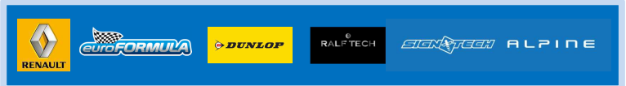[**facebook Join Nelson's Fan Club on Facebook!**](http://www.facebook.com/pages/Nelson-Panciatici/90065452450)