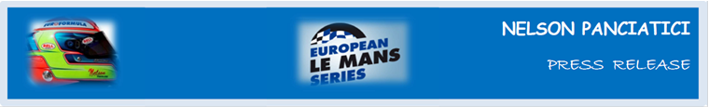
LE MANS 24 HOURS 2014 (June 14 & 15)
ALPINE AND NELSON PANCIATICI STEP UP ON THE PODIUM!

From the start, the Signatech-Alpine team and Nelson Panciatici lit up the most tightly fought LMP2 class with front-running positions. They ended with the third step of the podium and a seventh place in the overall standings of the Le Mans 24 Hours! If their battle to defend their ELMS title is their mission, the Le Mans 24 Hours is nevertheless the major event in which Alpine needed a solid result. Objective set and achieved.
Behind the wheel of an Alpine A450b, competing to the finish, Nelson Panciatici raced without a fault. Only two unexpected stops, quickly mastered by the technical team, cost them 15 minutes which deprived Alpine of the highest step on the podium.
For Nelson Panciatici, who also made the fastest time in class, there is satisfaction from this podium:
“It’s my first podium finish at the 24 Hours of Le Mans in three attempts. We showed we were fast throughout the race. I always keep a small margin at Le Mans because we have a great responsibility towards the team, but in my final relay I was given the green light to race as hard as I could and I really went for it. I was able to block out the pressure of the 24 Hours and really fight a race within the race for three hours. The result is a great reward for the whole team. I want to congratulate my co-drivers as well, Paul Loup Chatin and Oliver Webb, who were new to this race. Each and every one of us put in our best. I can’t wait for next year!”
Same satisfaction for Philippe Sinault, the Signatech-Alpine Team Manager:
«What a fight that was for 24 hours! This is a fantastic result for the whole team. I am happy to dedicate this race to all those who work with us to drive such projects forward. Last year we celebrated Alpine’s comeback to Le Mans. This time, we celebrate Alpine’s comeback on the podium of the 24 Hours! More importantly, we showed we have what it takes to win.”
The next meeting is on the circuit of the Red Bull Ring in Austria where the third leg of the European Le Mans Series will take place on July 19 and 20. The Signatech-Alpine team and their drivers will without doubt want to make the Alpine livery shine its colours again!
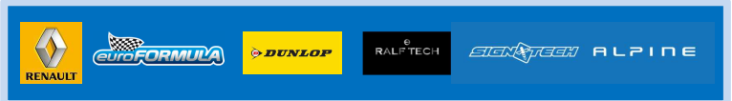
For more information on Nelson PANCIATICI, please visit www.nelsonpancia.fr
Join Nelson's Fan Club on Facebook!

